Drug Repurposing Report for Benazepril

Section 1. Current indication: what is the drug class? What is it currently approved to treat?
Drug Class = angiotensin-converting enzyme (ACE) inhibitors
It is currently approved to treat:
Disease | Hypertension
PMID, PMCID | Evidence Sentences
32314699 PMC7253125 | Past medical history was significant for hypertension, treated with amlodipine and benazepril, and chronic back pain.
32081428  PMC7092824 | On the other hand, many ACE inhibitors are currently used to treat hypertension and other cardiovascular diseases. Among them are captopril, perindopril, ramipril, lisinopril, benazepril, and moexipril.

Disease | Dogs with Congestive Heart Failure (CHF)
PMID | Evidence Sentences
31254308  PMC6639469 | 9-year-old male neutered Cocker Spaniel with severe CHF receiving furosemide, benazepril, hydrocodone, sildenafil, and pimobendan;

(2) path connecting drug and disease in KG

Disease | Covid-19
PMID, PMCID | Evidence Sentences
32081428, PMC7092824 | By using a molecular docking approach, an earlier study identified N-(2-aminoethyl)-1 aziridine-ethanamine as a novel ACE2 inhibitor that effectively blocks the SARS-CoV RBD-mediated cell fusion. This has provided a potential candidate and lead compound for further therapeutic drug development. Meanwhile, biochemical and cell-based assays can be established to screen chemical compound libraries to identify novel inhibitors. On the other hand, many ACE inhibitors are currently used to treat hypertension and other cardiovascular diseases. Among them are captopril, perindopril, ramipril, lisinopril, benazepril, and moexipril. Although these drugs primarily target ACE, a homolog of ACE2 with 42% sequence identity and 61% sequence similarity in the catalytic domain, they may be effective toward ACE2 as well.

Section 2. Molecular structure (symbols desired, but a pointer to a reference is also useful)
Benazepril (C₂₄H₂₈N₂O₅): an angiotensin converting enzyme (ACE) inhibitor, used alone or together with other medicines to treat high blood pressure (hypertension).
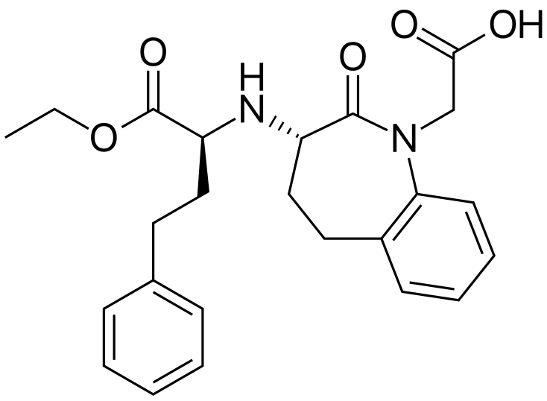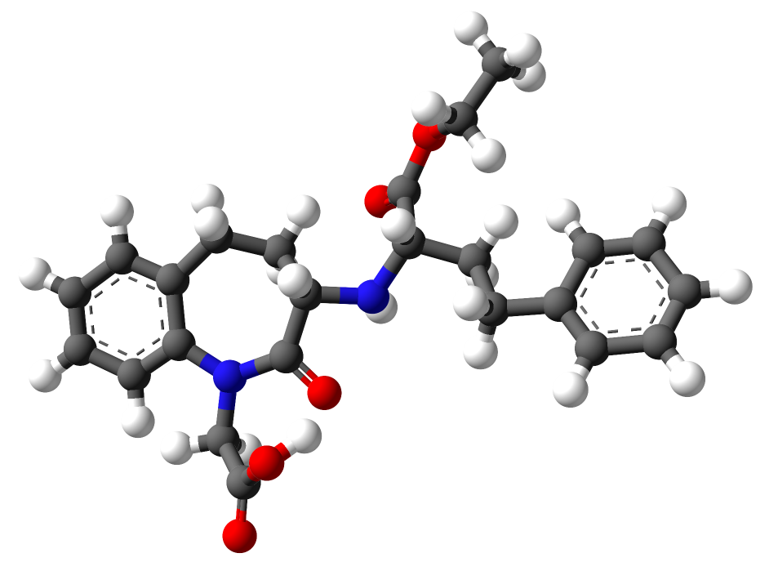
Figure: Molecular structure of Benazepril (src: wikipedia)

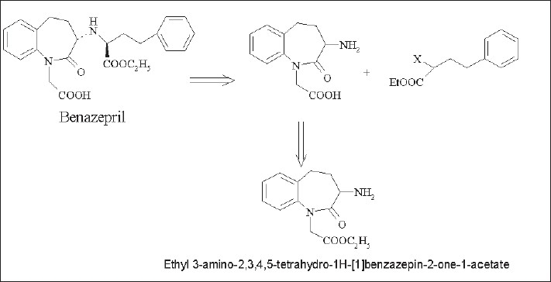
Figure: Retrosynthesis of benazepril (src: PMC3003176 Fig.1)

Section 3: Mechanism of action i.e. inhibits viral entry, replication, etc (w/ a pointer to data)
Pathogenic mechanisms of viral disease include (1) implantation of virus at the portal of entry (Drug inhibit COVID-19 -> Cell), (2) local replication (Drug inhibit COVID-19 DNA replication, Drug inhibit COVID-19 -> Gene), (3) spread to target organs (disease sites) (Drug inhibit COVID-19 -> Organ), and (4) spread to sites of shedding of virus into the environment (Drug inhibit COVID-19 -> Environment),

PMID | Chemical (ID) | Gene (ID) | Interaction | InteractionActions
18713951 | benazepril (MESH:C044946) | SLC15A1 (6564) | benazepril inhibits the reaction [SLC15A1 protein results in increased uptake of glycylsarcosine] | decreases^reaction, increases^uptake
19018797 | benazepril (MESH:C044946) | RELA (5970) | benazepril results in decreased phosphorylation of RELA protein | decreases^phosphorylation
20821936  16732983 | benazepril (MESH:C044946) | MMP2 (4313) | benazepril inhibits the reaction [Streptozocin results in decreased expression of MMP2 mRNA] | decreases^expression, decreases^reaction
1179862711867951161914231717713819018797 | benazepril (MESH:C044946) | TGFB1 (7040) | benazepril results in decreased expression of TGFB1 mRNA | decreases^expression
115010621179862719018797 | benazepril (MESH:C044946) | AGT (183) | benazepril results in decreased expression of AGT protein modified form | decreases^expression
111367008763405 | benazepril (MESH:C044946) | NPPA (4878) | benazepril results in decreased expression of NPPA mRNA | decreases^expression
1531534116364833 | benazepril (MESH:C044946) | ACE (1636) | benazepril results in decreased activity of ACE protein | decreases^activity
12652327128489191555535515793787157883531100783115498266 | benazepril (MESH:C044946) | ACE (1636) | ACE gene polymorphism affects the susceptibility to benazepril | affects^response to substance
16635409 | benazepril (MESH:C044946) | SMAD2 (4087) | benazepril affects the expression of SMAD2 protein | affects^expression
1673298320821936 | benazepril (MESH:C044946) | TIMP2 (7077) | benazepril inhibits the reaction [Streptozocin results in increased expression of TIMP2 mRNA] | decreases^reaction, increases^expression
20671225 | benazepril (MESH:C044946) | APOB (338) | Fluvastatin promotes the reaction [[Valsartan co-treated with benazepril] results in decreased expression of APOB protein] | affects^cotreatment, decreases^expression, increases^reaction
16775501 | benazepril (MESH:C044946) | TNF (7124) | [benazepril co-treated with Amlodipine] results in decreased expression of TNF protein | affects^cotreatment, decreases^expression
16635409 | benazepril (MESH:C044946) | SMAD2 (4087) | [benazepril co-treated with Irbesartan] affects the expression of SMAD2 mRNA | affects^cotreatment, affects^expression
21449848 | benazepril (MESH:C044946) | AGTR1 (185) | [AGT gene polymorphism co-treated with ACE2 gene polymorphism] affects the susceptibility to benazepril | affects^cotreatment, affects^response to substance

Section 4: Was the drug identified by manual or computation screen?
Disease | COVID-19
PMID, PMCID | Evidence Sentences
32081428  PMC7092824 | Among them are captopril, perindopril, ramipril, lisinopril, benazepril, and moexipril. Although these drugs primarily target ACE, a homolog of ACE2 with 42% sequence identity and 61% sequence similarity in the catalytic domain, they may be effective toward ACE2 as well  By using a molecular docking approach, an earlier study identified N-(2-aminoethyl)-1 aziridine-ethanamine as a novel ACE2 inhibitor that effectively blocks the SARS-CoV RBD-mediated cell fusion. This has provided a potential candidate and lead compound for further therapeutic drug development. Meanwhile, biochemical and cell-based assays can be established to screen chemical compound libraries to identify novel inhibitors.

Disease | Cardiovascular Disease
PMID, PMCID | Evidence Sentences
22800722  PMC7102827 | Currently, there are more than 10 ACE inhibitors marketed that are widely used as first-line therapy for cardiovascular diseases, including hypertension, heart failure, heart attack and left ventricular dysfunction. According to the functional moiety, they are divided into three types: thiol (captopril), carboxylate (benazepril, enalapril, lisinopril, moexipril, perindopril, quinapril, ramipril, trandolapril) or phosphate (fosinopril).  Structure-based drug screening has identified two ACE2 activators: a xanthenone (1-[(2-diethylamino)ethyl-amino]-4-(hydroxymethyl)-7-[(4-methylphenyl)sulphonyloxy]-9H-xanthene-9-one; XNT) and resorcinolnaphthalein.XNT hydrogen bonds with ACE2 residues Lys94, Tyr196, Gly205 and His 195, and resorcinolnaphthalein is involved in three hydrogen bonds with residues Gln98, Gln101 and Gly205. XNT and resorcinolnaphthalein modulate ACE2 activity possibly by two mechanisms.

Section 5: Who is studying the drug? (Source/lab name)

Researcher | Affiliation
Robert L Kruse | Division of Transfusion Medicine, Department of Pathology, Johns Hopkins University School of Medicine, Baltimore, MD.
Hua-Hao Fan | Beijing Advanced Innovation Center for Soft Matter Science and Engineering, College of Life Science and Technology, Beijing University of Chemical Technology, Beijing 100029, China.
Li-Qin Wang | Gansu Provincial Center for Disease Control and Prevention, Lanzhou, Gansu, China.
Wen-Li Liu | 1Department of Dermatology, The First Affiliated Hospital of Xi'an Jiaotong University, Xi'an, 710061 Shaanxi China.
Xiao-Ping An | College of Animal Science, Inner Mongolia Agricultural University, Hohhot, 010018, China.
Zhen-Dong Liu | Key Laboratory of Saline-alkali Vegetation Ecology Restoration, Ministry of Education/Alkali Soil Natural Environmental Science Center, Northeast Forestry University, Harbin 150040, China. liu304418091@126.com.
Xiao-Qi He
Li-Hua Song | School of Agriculture and Biology, Shanghai Jiao Tong University, Shanghai, 200240, People's Republic of China. lihuas@sjtu.edu.cn.
Yi-Gang Tong | Beijing Advanced Innovation Center for Soft Matter Science and Engineering (BAIC-SM), College of Life Science and Technology, Beijing University of Chemical Technology, Beijing, P. R. China.
Pei-Fang Wei
Jin Soo Shin | Infectious Diseases Therapeutic Research Center, Korea Research Institute of Chemical Technology (KRICT), Daejeon 34114, Korea.
Eunhye Jung | Virus Research Group, Korea Research Institute of Chemical Technology, Daejeon, Republic of Korea.
Meehyein Kim | Infectious Diseases Therapeutic Research Center, Korea Research Institute of Chemical Technology (KRICT), Daejeon 34114, Korea.
Ralph S Baric | Department of Microbiology and Immunology, University of North Carolina School of Medicine, Chapel Hill NC 27599, USA.
Yun Young Go | Virus Research Group, Korea Research Institute of Chemical Technology, Daejeon, Republic of Korea. yygo@krict.re.kr.
Junwen Luan | Institute of Basic Medicine, Shandong Provincial Hospital Affiliated to Shandong First Medical University, Jinan 250062, Shandong, China.
Yue Lu | Department of Epigenetics and Molecular Carcinogenesis, University of Texas M.D. Anderson Cancer Center, Science Park, Smithville, TX, 78957, USA.
Xiaolu Jin | Institute of Basic Medicine, Shandong Provincial Hospital Affiliated to Shandong First Medical University, Jinan, Shandong, China.
Leiliang Zhang | Institute of Basic Medicine, Shandong Provincial Hospital Affiliated to Shandong First Medical University, Jinan 250062, Shandong, China. Electronic address: armzhang@hotmail.com.
Renhong Yan | Key Laboratory of Structural Biology of Zhejiang Province, School of Life Sciences, Westlake University, Hangzhou, China.
Yuanyuan Zhang | College of Pharmacy, Shandong University of Traditional Chinese Medicine, Jinan, China.
Yaning Li | State Key Laboratory of Satellite Navigation System and Equipment Technology, Shijiazhuang 050081, China.
Lu Xia | Shanghai Public Health Clinical Center, Fudan University, Shanghai, People's Republic of China.
Yingying Guo | Department of Cardiothoracic Surgery, The Affiliated Hospital of Jiangnan University, Wuxi, Jiangsu, China.
Qiang Zhou | Department of Molecular and Cell Biology, University of California, Berkeley, CA 94720, USA.
Elizabeth A Nelson | Department of Medical Education, Dell Medical School, University of Texas at Austin, Austin, Texas, USA.
Julie Dyall | Integrated Research Facility, National Institute of Allergy and Infectious Diseases, National Institutes of Health, Frederick, MD, 21702, USA. dyallj@niaid.nih.gov.
Thomas Hoenen | Institute of Molecular Virology and Cell Biology, Friedrich-Loeffler-Institut, Greifswald - Insel Riems, Germany.
Alyson B Barnes | Department of Cell Biology, University of Virginia, Charlottesville, Virginia, United States of America.
Huanying Zhou | Tianjin Key Laboratory of Risk Assessment and Control Technology for Environment and Food Safety, Tianjin Institute of Environmental and Operational Medicine, Tianjin 300050, China.
Janie Y Liang | Integrated Research Facility, Division of Clinical Research, National Institute of Allergy and Infectious Diseases, National Institutes of Health, Frederick, Maryland, United States of America.
Julia Michelotti | Integrated Research Facility, Frederick, Maryland.
William H Dewey | Integrated Research Facility, Division of Clinical Research, National Institute of Allergy and Infectious Diseases, National Institutes of Health, Frederick, Maryland, United States of America.
Lisa Evans DeWald | Emergent BioSolutions, Gaithersburg, Maryland.
Richard S Bennett | Integrated Research Facility, Division of Clinical Research, National Institute of Allergy and Infectious Diseases, National Institutes of Health, Research Plaza, Frederick, Maryland, United States of America.
Patrick J Morris | Division of Preclinical Innovation, National Center for Advancing Translational Sciences, National Institutes of Health, Rockville, MD 20850, USA.
Rajarshi Guha | Division of Preclinical Innovation, National Center for Advancing Translational Sciences, National Institutes of Health, Rockville, Maryland, United States.
Carleen Klumpp-Thomas | National Center for Advancing Translational Sciences, 9800 Medical Center Drive, Rockville, MD, 20850.
Crystal McKnight | Division of Preclinical Innovation, National Center for Advancing Translational Sciences, National Institutes of Health, Rockville, MD 20850, USA.
Yu-Chi Chen | Institute of Clinical Nursing, School of Nursing, National Yang-Ming University, Taipei, Taiwan.
Xin Xu | Henan Provincial Engineering Laboratory of Insects Bio-reactor, Henan Provincial Engineering and Technology Center of Health Products for Livestock and Poultry, Henan Provincial Engineering and Technology Center of Animal Disease Diagnosis and Integrated Control, Nanyang Normal University, Nanyang, 473061, PR China.
Amy Wang | Predicine, Inc., Hayward, CA, United States.
Emma Hughes | Department of Bioengineering and Therapeutic Sciences, University of California San Francisco, San Francisco, California, USA.
Scott Martin | DMPK/ADME Research and Early Development, Oncology R&D, AstraZeneca, Cambridge, UK.
Craig Thomas | Research Institute for Sport and Exercise Sciences (RISES), Liverpool John Moores University, Tom Reilly Building, Byrom St. Campus, Liverpool, L3 3AF, UK.
Peter B Jahrling | Integrated Research Facility at Fort Detrick, National Institute of Allergy and Infectious Diseases, National Institutes of Health, Fort Detrick, Frederick, MD, USA.
Lisa E Hensley | Integrated Research Facility, Division of Clinical Research, National Institute of Allergy and Infectious Diseases, National Institutes of Health, Research Plaza, Frederick, Maryland, United States of America.
Gene G Olinger | Integrated Research Facility, Division of Clinical Research, National Institute of Allergy and Infectious Diseases, National Institutes of Health, Frederick, Maryland, United States of America.
Judith M White | Department of Cell Biology, University of Virginia, Charlottesville, Virginia, USA.
Fatah Kashanchi | National Center for Biodefense and Infectious Diseases, George Mason University, Manassas, VA 20110, USA.
Qihui Wang | CAS Key Laboratory of Pathogenic Microbiology and Immunology, Institute of Microbiology, Chinese Academy of Sciences (CAS), Beijing 100101, China.
Yanfang Zhang | State Key Laboratory of Virology, Wuhan Institute of Virology, Chinese Academy of Sciences, Wuhan, 430071, China.
Lili Wu | Department of Cardiology, Key Laboratory of Cardiovascular Intervention and Regenerative Medicine of Zhejiang Province, Sir Run Run Shaw Hospital, School of Medicine, Zhejiang University, 3 East Qingchun Road, Hangzhou, Zhejiang, 310016, P.R. China.
Sheng Niu | College of Animal Science and Veterinary Medicine, Shanxi Agricultural University, Taigu 030801, China.
Chunli Song | Department of Orthopaedics, Peking University Third Hospital, Beijing, China. schl@bjmu.edu.cn and Beijing Key Laboratory of Spinal Diseases, 49 North Garden Rd Haidian District, Beijing, China.
Zengyuan Zhang | CAS Key Laboratory of Pathogenic Microbiology and Immunology, Institute of Microbiology, Chinese Academy of Sciences, Beijing 100101, China; University of the Chinese Academy of Sciences, Beijing 100049, China.
Guangwen Lu | West China Hospital Emergency Department (WCHED), State Key Laboratory of Biotherapy, West China Hospital, Sichuan University, and Collaborative Innovation Center of Biotherapy, Chengdu, Sichuan 610041, China.
Chengpeng Qiao | CAS Key Laboratory of Microbial Physiological and Metabolic Engineering, Institute of Microbiology, Chinese Academy of Sciences, Beijing 100101, China.
Yu Hu | Department of Pathology, China-Japan Union Hospital, Jilin University, Changchun, Jilin, China.
Kwok-Yung Yuen | Department of Microbiology and State Key Laboratory for Emerging Infectious Diseases, Li Ka Shing Faculty of Medicine, The University of Hong Kong, Hong Kong SAR, People's Republic of China.
Qisheng Wang | Shanghai Synchrotron Radiation Facility, Shanghai Institute of Applied Physics, Chinese Academy of Sciences, Shanghai, China.
Huan Zhou | West China School of Public Health and West China Forth Hospital, Sichuan University, Chengdu, China.
Jinghua Yan | CAS Key Laboratory of Pathogenic Microbiology and Immunology, Institute of Microbiology, Chinese Academy of Sciences (CAS), Beijing 100101, China.
Jianxun Qi | CAS Key Laboratory of Pathogenic Microbiology and Immunology, Institute of Microbiology, Chinese Academy of Sciences (CAS), Beijing 100101, China.
Rui Li | College of Resources and Environmental Science, Northeast Agricultural University, Harbin, 150030, China.
Songlin Qiao | Key Laboratory of Animal Immunology of the Ministry of Agriculture, Henan Provincial Key Laboratory of Animal Immunology, Henan Academy of Agricultural Sciences, Zhengzhou, Henan, China.
Gaiping Zhang | College of Animal Science and Veterinary Medicine, Henan Agricultural University, Zhengzhou, Henan, China lirui860620@sina.com zhanggaip@126.com.
Karam Khaddour | Department of Internal Medicine, Rosalind Franklin University of Medicine and Science, North Chicago, Illinois.
Anna Sikora | Department of Internal Medicine, Chicago Medical School, Rosalind Franklin University, Northwestern McHenry Hospital, McHenry, IL, USA.
Nayha Tahir | Department of Internal Medicine, Rosalind Franklin University of Medicine and Science, North Chicago, Illinois.
Daniel Nepomuceno | Department of Intensive Care, Northwestern Medicine McHenry Hospital, McHenry, Illinois.
Tian Huang | Department of Hematology, Guangdong Provincial People's Hospital, Guangdong Academy of Medical Sciences, Guangzhou, Guangdong 510080, PR China; South China University of Technology, Guangzhou, Guangdong 510006, PR China.
Yanxiao Han | Department of Chemistry, University of Illinois at Chicago, Chicago, Illinois 60607, United States.
Petr Král | Department of Biopharmaceutical Sciences, University of Illinois at Chicago, Chicago, Illinois 60612, United States.
Chaolin Huang | Jin Yin-tan Hospital, Wuhan, China.
Yeming Wang | Department of Pulmonary and Critical Care Medicine, Laboratory of Clinical Microbiology and Infectious Diseases, Center for Respiratory Diseases, National Clinical Research Center of Respiratory Diseases, China-Japan Friendship Hospital, Beijing, China.
Xingwang Li | Department of Anesthesiology, The Second Affiliated Hospital and Yuying Children's Hospital of Wenzhou Medical University, Wenzhou, Zhejiang, 325027, People's Republic of China.
Lili Ren | NHC Key Laboratory of Systems Biology of Pathogens and Christophe Mérieux Laboratory, Institute of Pathogen Biology, Chinese Academy of Medical Sciences (CAMS) & Peking Union Medical College, Beijing, China.
Jianping Zhao | National Center for Natural Products Research, Research Institute of Pharmaceutical Sciences, University of Mississippi, MS, USA.
Yi Hu | Key Laboratory of Mesoscopic Chemistry of MOE, School of Chemistry and Chemical Engineering, Nanjing University, Nanjing, Jiangsu 210023, China. zhongjin@nju.edu.cn.
Li Zhang | Jiangsu Key Laboratory for High Technology Research of TCM Formulae, National and Local Collaborative Engineering Center of Chinese Medicinal Resources Industrialization and Formulae Innovative Medicine and Jiangsu Collaborative Innovation Center of Chinese Medicinal Resources Industrialization, Nanjing University of Chinese Medicine, Nanjing, China.
Guohui Fan | Institute of Clinical Medical Sciences, China-Japan Friendship Hospital, Beijing, China.
Jiuyang Xu | Department of Basic Medical Sciences, Tsinghua University School of Medicine, Beijing, China.
Xiaoying Gu | Department of Epidemiology, Tulane University School of Public Health and Tropical Medicine, New Orleans, LA 70112, USA.
Zhenshun Cheng | Zhongnan Hospital of Wuhan University, Wuhan, China.
Ting Yu | School of Nursing, Tongji Medical College, Huazhong University of Science and Technology, Wuhan, Hubei, China.
Jiaan Xia | From the Department of Pulmonary and Critical Care Medicine, Center of Respiratory Medicine, National Clinical Research Center for Respiratory Diseases (B.C., Yeming Wang, G.F., F.Z., X.G., Z.L., Y.Z., Hui Li, L.S., C.W.), and the Institute of Clinical Medical Sciences (G.F., X.G.), China-Japan Friendship Hospital, the Institute of Respiratory Medicine, Chinese Academy of Medical Sciences (B.C., Yeming Wang, F.Z., Z.L., Y.Z., Hui Li, C.W.), the Clinical and Research Center of Infectious Diseases, Beijing Ditan Hospital, Capital Medical University (Xingwang Li), Peking University Clinical Research Institute, Peking University First Hospital (C.D.), Tsinghua University School of Medicine (Jiuyang Xu), Beijing University of Chinese Medicine (L.S.), NHC Key Laboratory of Systems Biology of Pathogens and Christophe Merieux Laboratory, Institute of Pathogen Biology, Chinese Academy of Medical Sciences (L.G.), and Peking Union Medical College (L.G., C.W.), Beijing, and Jin Yin-tan Hospital, Wuhan (D.W., W.L., Jingli Wang, L.R., B.S., Y.C., M.W., Jiaan Xia, N.C., Jie Xiang, T.Y., T.B., X.X., L.Z., C.L., Y.Y., H.C., Huadong Li, H.H., S.T., F.G., Y.L., Yuan Wei, K.W., K.L., X.Z., X.D., Z.Q., Sixia Lu, X.H., S.R., Shanshan Luo, Jing Wu, Lu Peng, F.C., Lihong Pan, J.Z., C.J., Juan Wang, Xia Liu, S.W., X.W., Q.G., J.H., H.Z., F.Q., C.H., D.Z.) - all in China; Lancaster University, Lancaster (T.J.), and the University of Oxford, Oxford (P.W.H.) - both in the United Kingdom; and the University of Virginia School of Medicine, Charlottesville (F.G.H.).
Yuan Wei | Three Wards of Outpatient Service, Wuhan Jin Yin Tan Hospital, No.1 Yintan Road, Dongxihu District, Wuhan, 433013, Hubei, China. touyuangeng695@163.com.
Wenjuan Wu | Department of Respiratory, The Second Affiliated Hospital of Kunming Medical University, Kunming 650101, Yunnan, China.
Xuelei Xie | From the Department of Pulmonary and Critical Care Medicine, Center of Respiratory Medicine, National Clinical Research Center for Respiratory Diseases (B.C., Yeming Wang, G.F., F.Z., X.G., Z.L., Y.Z., Hui Li, L.S., C.W.), and the Institute of Clinical Medical Sciences (G.F., X.G.), China-Japan Friendship Hospital, the Institute of Respiratory Medicine, Chinese Academy of Medical Sciences (B.C., Yeming Wang, F.Z., Z.L., Y.Z., Hui Li, C.W.), the Clinical and Research Center of Infectious Diseases, Beijing Ditan Hospital, Capital Medical University (Xingwang Li), Peking University Clinical Research Institute, Peking University First Hospital (C.D.), Tsinghua University School of Medicine (Jiuyang Xu), Beijing University of Chinese Medicine (L.S.), NHC Key Laboratory of Systems Biology of Pathogens and Christophe Merieux Laboratory, Institute of Pathogen Biology, Chinese Academy of Medical Sciences (L.G.), and Peking Union Medical College (L.G., C.W.), Beijing, and Jin Yin-tan Hospital, Wuhan (D.W., W.L., Jingli Wang, L.R., B.S., Y.C., M.W., Jiaan Xia, N.C., Jie Xiang, T.Y., T.B., X.X., L.Z., C.L., Y.Y., H.C., Huadong Li, H.H., S.T., F.G., Y.L., Yuan Wei, K.W., K.L., X.Z., X.D., Z.Q., Sixia Lu, X.H., S.R., Shanshan Luo, Jing Wu, Lu Peng, F.C., Lihong Pan, J.Z., C.J., Juan Wang, Xia Liu, S.W., X.W., Q.G., J.H., H.Z., F.Q., C.H., D.Z.) - all in China; Lancaster University, Lancaster (T.J.), and the University of Oxford, Oxford (P.W.H.) - both in the United Kingdom; and the University of Virginia School of Medicine, Charlottesville (F.G.H.).
Wen Yin | State Key Laboratory of Agricultural Microbiology, College of Life Science and Technology, Huazhong Agricultural University, Wuhan, Hubei 430070, P. R. China.
Hui Li | Center for Proteomics and Metabolomics, State Key Laboratory of Biocontrol, Guangdong Province Key Laboratory for Pharmaceutical Functional Genes, School of Life Sciences, Sun Yat-sen University, University City, Guangzhou, People's Republic of China.
Min Liu | School of Pharmacy, Anhui University of Chinese Medicine, Hefei, China.
Yan Xiao | CAS Key Laboratory on Reservoir Water Environment, Chongqing Institute of Green and Intelligent Technology, Chinese Academy of Sciences; No. 266 Fangzheng Avenue, Shuitu Hi-tech Industrial Park, Shuitu Town, Beibei District, Chongqing 400714, China.
Hong Gao | National Clinical Research Center for Infectious Diseases, Shenzhen Third People's Hospital, Southern University of Science and Technology, Shenzhen, People's Republic of China.
Li Guo | Department of Center Laboratory, The Second Affiliated Hospital of Jiaxing University, Jiaxing, China.
Jungang Xie | Department of Respiratory and Critical Care Medicine, Key Laboratory of Pulmonary Diseases of Health Ministry, Key Cite of National Clinical Research Center for Respiratory Disease, Tongji Hospital, Tongji Medical College Huazhong University of Science and Technology, No. 1095 Jie Fang Avenue, 430030, Wuhan, China.
Guangfa Wang | Department of Respiratory Medicine, Peking University First Hospital, Beijing 100034, People's Republic of China.
Rongmeng Jiang | 1Department of Infectious Disease, Beijing Ditan Hospital, Capital Medical University, No. 8 East Jingshun Street, Chaoyang District, Beijing, 100015 China.
Zhancheng Gao | Dept of Respiratory and Critical Care Medicine, Peking University People's Hospital, Beijing, China zcgao@bjmu.edu.cn.
Qi Jin | School of Pharmaceutical Sciences, Gannan Medical University, Ganzhou, 341000, Jiangxi Province, P. R. China. zhangjiangnmc031@163.com luorenshi2010@163.com.
Jianwei Wang | Department of Pathogen Biology-Microbiology Division, State Key Laboratory of Reproductive Medicine, Key Laboratory of Pathogen Biology of Jiangsu Province, Center for Global Health, Nanjing Medical University , Nanjing, China.
Bin Cao | Tsinghua University-Peking University Joint Center for Life Sciences, Beijing, China.
Siwaporn Boonyasuppayakorn | Applied Medical Virology Research Unit, Department of Microbiology, Faculty of Medicine, Chulalongkorn University, Bangkok 10330, Thailand.
Erin D Reichert | Department of Microbiology & Immunology, Georgetown University, USA. Electronic address: erin.reichert@dtra.mil.
Mark Manzano | Department of Microbiology-Immunology, Northwestern University Feinberg School of Medicine, Chicago, IL 60611, USA.
Kuppuswamy Nagarajan | R&D Centre, Alkem Laboratories Ltd. , Peenya Ind. Area, 3rd Stage, Bangalore 560 058, India.
Radhakrishnan Padmanabhan | Department of Microbiology and Immunology, Georgetown University, Washington, DC, USA paa9@georgetown.edu rp55@georgetown.edu.
Leeor Zilbermintz | Keck Graduate Institute, Claremont, CA 91711, USA.
William Leonardi | Keck Graduate Institute, Claremont, CA 91711, USA.
Sun-Young Jeong | Keonyang University College of Nursing, Daejeon, Korea.
Megan Sjodt | Department of Biological Chemistry and Molecular Pharmacology, Blavatnik Institute, Harvard Medical School, Boston, MA, USA.
Ryan McComb | Private Practice of Orthodontics in Los Angeles.
Chi-Lee C Ho | Department of Microbiology, Immunology and Molecular Genetics , University of California, Los Angeles , 609 Charles E. Young Drive East , Los Angeles , California 90095 , United States.
Cary Retterer | United States Army Medical Research Institute of Infectious Diseases (USAMRIID), 1425 Porter Street, Frederick, MD, 21702, USA.
Dima Gharaibeh | United States Army Medical Research Institute of Infectious Diseases (USAMRIID), 1425 Porter Street, Fort Detrick, Frederick, MD, 21702, USA.
Rouzbeh Zamani | United States Army Medical Research Institute of Infectious Diseases (USAMRIID), 1425 Porter Street, Frederick, MD, 21702, USA.
Veronica Soloveva | U.S. Army Medical Research Institute of Infectious Diseases, Frederick, MD, 21702-5011, USA.
Sina Bavari | United States Army Medical Research Institute of Infectious Diseases (USAMRIID), Frederick, MD, USA.
Anastasia Levitin | School of Applied Life Sciences , Keck Graduate Institute , 535 Watson Drive , Claremont , California 91711 , United States.
Joel West | Keck Graduate Institute, Claremont, CA 91711.
Kenneth A Bradley | Department of Microbiology, Immunology and Molecular Genetics , University of California, Los Angeles , 609 Charles E. Young Drive East , Los Angeles , California 90095 , United States.
Robert T Clubb | Department of Chemistry and Biochemistry, University of California, Los Angeles, USA. rclubb@mbi.ucla.edu.
Stanley N Cohen | Department of Genetics, Stanford University School of Medicine, Stanford, CA 94305, USA.
Vivek Gupta | Department of Pharmaceutical Sciences, College of Pharmacy and Health Sciences, St. John's University, 8000 Utopia Parkway, Queens, New York, 11439, USA. guptav@stjohns.edu.
Mikhail Martchenko | School of Applied Life Sciences , Keck Graduate Institute , 535 Watson Drive , Claremont , California 91711 , United States.
Yushun Wan | Department of Veterinary and Biomedical Sciences, College of Veterinary Medicine, University of Minnesota, Saint Paul, MN 55108.
Jian Shang | Department of Veterinary and Biomedical Sciences, College of Veterinary Medicine, University of Minnesota, Saint Paul, MN 55108.
Rachel Graham | Department of Epidemiology, University of North Carolina, Chapel Hill, North Carolina, USA.
Ralph S Baric | Department of Microbiology and Immunology, University of North Carolina School of Medicine, Chapel Hill NC 27599, USA.
Fang Li | Key Laboratory of New Materials and Facilities for Rural Renewable Energy Ministry of Agriculture, Henan Agricultural University, Zhengzhou, China.
Tom Gallagher | Department of Microbiology and Immunology, Loyola University Chicago, Maywood, IL 60153, USA. Electronic address: tgallag@luc.edu.
Wanbo Tai | Laboratory of Viral Immunology, Lindsley F. Kimball Research Institute, New York Blood Center, New York, NY 10065, USA.
Lei He | The Key Lab of Animal Disease and Public Health, Henan University of Science and Technology, 263 Kaiyuan Avenue, Luoyang, 471023, Henan, China.
Xiujuan Zhang | Department of Endocrinology, Shandong Provincial Hospital Affiliated to Shandong University, Jinan, Shandong, China.
Jing Pu | Key Laboratory of Medical Molecular Virology (MOE/NHC/CAMS), School of Basic Medical Sciences and Shanghai Public Health Clinical Center, Fudan University, 130 Dong An Rd., Xuhui District, Shanghai 200032, China.
Denis Voronin | Lindsley F. Kimball Research Institute, New York Blood Center, New York, NY, USA.
Shibo Jiang | Key Laboratory of Medical Molecular Virology (MOE/NHC/CAMS), School of Basic Medical Sciences and Shanghai Public Health Clinical Center, Fudan University, 130 Dong An Rd., Xuhui District, Shanghai 200032, China. lul@fudan.edu.cn shibojiang@fudan.edu.cn qinchuan@pumc.edu.cn.
Yusen Zhou | State Key Laboratory of Pathogen and Biosecurity, Beijing Institute of Microbiology and Epidemiology, Beijing, China.
Lanying Du | Laboratory of Viral Immunology, Lindsley F. Kimball Research Institute, New York Blood Center, New York, NY 10065, USA.
Yun Chen | Institute of Biotechnology, State Key Laboratory of Rice Biology, Key Laboratory of Molecular Biology of Crop Pathogens and Insects, Zhejiang University, Hangzhou, 310058, China.
Yao Guo | Nursing College of Henan University of Chinese Medicine, Zhengzhou, Henan, China.
Yihang Pan | Tomas Lindahl Nobel Laureate Laboratory, the Seventh Affiliated Hospital of Sun Yat-sen University, Shenzhen, Guangdong, 518107, P. R. China.
Zhizhuang Joe Zhao | Edmond H. Fischer Signal Transduction Laboratory, College of Life Sciences, Jilin University, Changchun, China. joe-zhao@ouhsc.edu.
Markus Hoffmann | Deutsches Primatenzentrum-Leibniz Institute for Primate Research, Göttingen, Germany.
Hannah Kleine-Weber | Deutsches Primatenzentrum-Leibniz Institute for Primate Research, Göttingen, Germany.
Simon Schroeder | Charité-Universitätsmedizin Berlin, corporate member of Freie Universität Berlin, Humboldt-Universität zu Berlin, and Berlin Institute of Health, Institute of Virology, Berlin, Germany.
Nadine Krüger | Institute of Virology, University of Veterinary Medicine Hannover, Hannover, Germany; Research Center for Emerging Infections and Zoonoses, University of Veterinary Medicine Hannover, Hannover, Germany.
Tanja Herrler | Department of Hand Surgery, Trauma Center Murnau, Murnau, Germany.
Sandra Erichsen | Institute for Biomechanics, BG Unfallklinik Murnau, Murnau, Germany; Institute for Biomechanics, Paracelsus Medical University Salzburg, Salzburg, Austria.
Tobias S Schiergens | Department of General, Visceral, and Transplant Surgery, Ludwig-Maximilians-University Munich, Munich, Germany.
Georg Herrler | Institute of Virology, University of Veterinary Medicine Hannover, 30559 Hannover, Germany.
Nai-Huei Wu | Institute of Virology, University of Veterinary Medicine Hannover, 30559 Hannover, Germany.
Andreas Nitsche | Centre for Biological Threats and Special Pathogens 1 - Highly Pathogenic Viruses & German Consultant Laboratory for Poxviruses & WHO Collaborating Centre for Emerging Infections and Biological Threats, Robert Koch Institute, Berlin, Germany.
Marcel A Müller | Charité-Universitätsmedizin Berlin, corporate member of Freie Universität Berlin, Humboldt-Universität zu Berlin, and Berlin Institute of Health, Institute of Virology, Berlin, Germany.
Christian Drosten | Charité-Universitätsmedizin Berlin, corporate member of Freie Universität Berlin, Humboldt-Universität zu Berlin, and Berlin Institute of Health, Institute of Virology, Berlin, Germany.
Stefan Pöhlmann | Deutsches Primatenzentrum-Leibniz Institute for Primate Research, Göttingen, Germany spoehlmann@dpz.eu.
David Gurwitz | Department of Human Molecular Genetics and Biochemistry, Sackler Faculty of Medicine, Tel Aviv, Israel.

Section 6: In vitro Data available (cell line used, assays run, viral strain used, cytopathic effects, toxicity, LD50, dosage response curve, etc)

Disease | Cardiovascular disease
PMID, PMCID | Evidence Sentences
22800722  PMC7102827 | The in vitro half-maximal inhibitory concentration (IC50) values of food-derived ACE inhibitory peptides are about 1000-fold higher than that of synthetic captopril but they have higher in vivo activities than would be expected from their in vitro activities.....  Germinal ACE depends on chloride to a lesser extent compared with the C domain of sACE. Cushman and Cheung reported an optimal in vitro ACE activity of rabbit rung acetone extract in the presence of 300 mM NaCl at pH 8.1-8.3…

Section 7: Animal Data Available (what animal model, LD50, dosage response curve, etc)

Disease | Feline Infectious Peritonitis
PMID, PMCID | Evidence Sentences
21216644  PMC7129202 | The in vitro half-maximal inhibitory concentration (IC50) values of food-derived ACE inhibitory peptides are about 1000-fold higher than that of synthetic captopril but they have higher in vivo activities than would be expected from their in vitro activities.....  Germinal ACE depends on chloride to a lesser extent compared with the C domain of sACE. Cushman and Cheung reported an optimal in vitro ACE activity of rabbit rung acetone extract in the presence of 300 mM NaCl at pH 8.1-8.3…

Section 8: Clinical trials on going (what phase, facility, target population, dosing, intervention etc)

Disease | Cardiovascular disease
PMID, PMCID | Evidence Sentences
18804122  PMC7112668 | On the basis of several large-scale clinical trials, it is now accepted that chronic inhibition of the RAS can provide neuroprotection, with reduced occurrence of stroke in high-risk populations.

Section 9: Funding source (who is funding each of the above, it might be different for in vitro vs animal vs clinical)

PMCID | Trial Type | Funding source
PMC7102827 | Vitro | This work was supported partly by Fundamental Research Funds for the Central Universities (JUSRP211A06) and the Self-Determined Research Program of Jiangnan University (No. 5815210232110800 & No. 5815210372100530).
PMC7129202 | Animal Data
PMC7112668 | Clinical trials | The original research findings discussed in this review were supported by Project Grants from the National Health and Medical Research Council (NHMRC) of Australia (ID 143564; 384237 and 436823).

Section 10: List of relevant sources to pull data from.

[1] https://www.ncbi.nlm.nih.gov/research/pubtator/index.html
[2] https://www.semanticscholar.org/cord19/download
[3] Wang, Lucy Lu et al. “CORD-19: The Covid-19 Open Research Dataset.” ArXiv (2020): n. Pag.
[4] Wei, Chih-Hsuan, et al. “PubTator Central: Automated Concept Annotation for Biomedical Full Text Articles.” Nucleic Acids Research, vol. 47, no. W1, Oxford Academic, July 2019, pp. W587–93. academic.oup.com, doi:10.1093/nar/gkz389.

Drug Repurposing Report for Losartan

Section 1. Current indication: what is the drug class? What is it currently approved to treat?

Drug Class = angiotensin receptor blockers (ARBs)

Disease | COVID-19
PMID, PMCID | Evidence Sentences
32265180  PMC7138183 | Gurwitz suggested using available angiotensin receptor 1 (AT1R) blockers, such as losartan, as therapeutics for reducing the severity of COVID-19 infections.
32227760  PMC7121452 | In addition, paired trials of losartan as a treatment for Covid-19 are being conducted among patients who have not previously received treatment with a RAAS inhibitor and are either hospitalized (NCT04312009) or not hospitalized (NCT04311177).

Disease | Fibrotic and cancer related diseases
PMID, PMCID | Evidence Sentences
28390872  PMC5507769 | Upstream of TGF-beta signaling, there are several FDA approved drugs (Losartan, Pirfenidone and Tranilast) that have effects at lowering TGF-beta levels in the host.

Disease | Impaired lung function
PMID, PMCID | Evidence Sentences
25890286  PMC4395934 | Importantly, the administration of losartan prolonged the overall survival time of G5 PAMAM-treated wild type mice (Figure 4A), markedly alleviated their impaired lung function (Figure 4B), attenuated their increased AngII production (Figure 4C), reduced the increased wet-to-dry weight ratio of their lung tissue (Figure 4D), and improved the decreased blood oxygenation (Figure 4E).

Disease | Cardiovascular disease
PMID, PMCID | Evidence Sentences
28390872  PMC5507769 | We now report that losartan and cinanserin inhibit GPVI-mediated platelet activation in a selective, competitive and dose-dependent manner.

Disease | Hypertension
PMID, PMCID | Evidence Sentences
30145617  PMC7101636 | Table 1 Current approved treatments for hypertension Plendil Felodipine DHP-CCB PO 1994 Cozaar Losartan ARB PO 1995 Hyzaar Losartan/HCTZ ARB/thiazide PO 1995
32283298  PMC7156148 | Table 1 List of approved drugs repurposed on various diseases.  Losartan (85) High blood pressure, heart failure and diabetic kidney disease Alzheimer’s disease
32129518  PMC7228359 | Losartan, telmisartan, olmesartan (and additional AT1R antagonists) are widely applied in the clinic since the 1990s for control of hypertension and kidney disorders, and are known as safe drugs that are rarely implicated in adverse drugs events

(2) path connecting drug and disease in KG

Disease | Covid-19
PMID, PMCID | Evidence Sentences
32129518  PMC7228359 | A tentative suggestion based on existing therapeutics, which would likely be resistant to new coronavirus mutations, is to use available angiotensin receptor 1 (AT1R) blockers, such as losartan, as therapeutics for reducing the aggressiveness and mortality from SARS‐CoV‐2 virus infections.
32356926  PMC7267340 | Recently, Gurwitz proposed the tentative use of agents such as losartan and telmisartan as alternative options for treating COVID‐19 patients prior to development of ARDS.

Section 2. Molecular structure (symbols desired, but a pointer to a reference is also useful)
Losartan (C₂₂H₂₃CIN₆O):
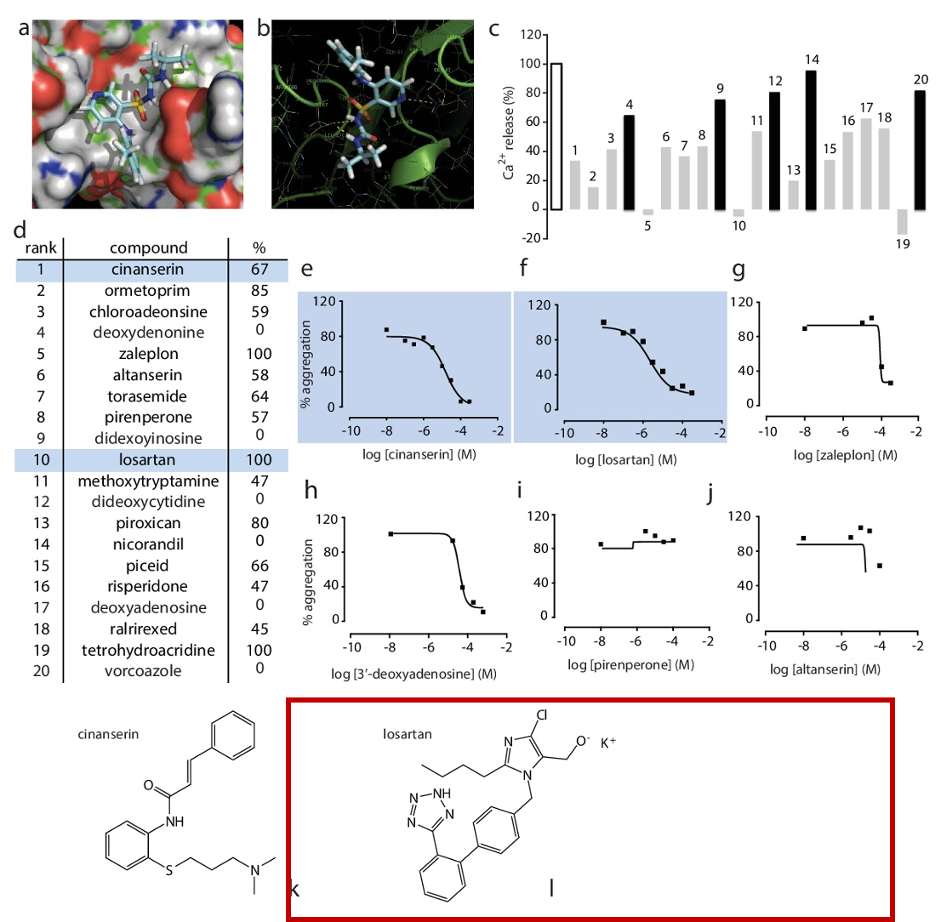
Figure: Molecular structure of Losartan (src: PMC4074120 Fig.1 In silico identifies GPVI antagonists)
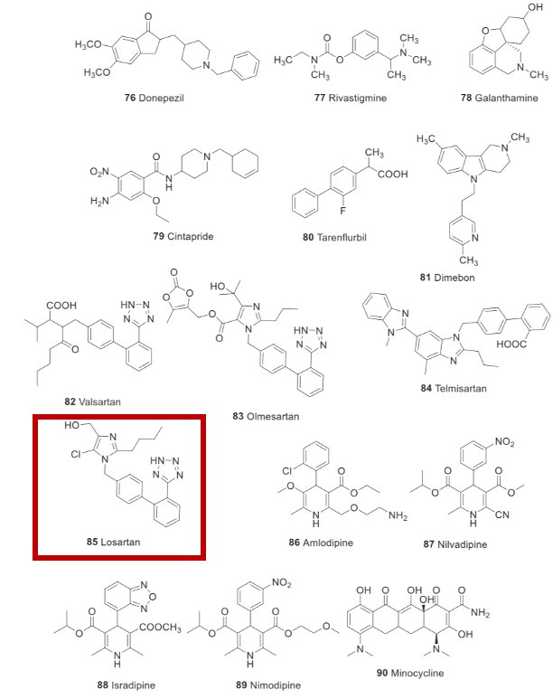
Figure: Molecular structure of Losartan (src: PMC7156148 Fig. 7 Drugs repurposed for Alzheimer)
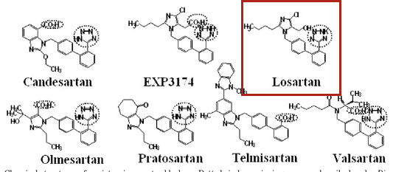
Figure: Molecular structure of Losartan (src: PMID 17043154)
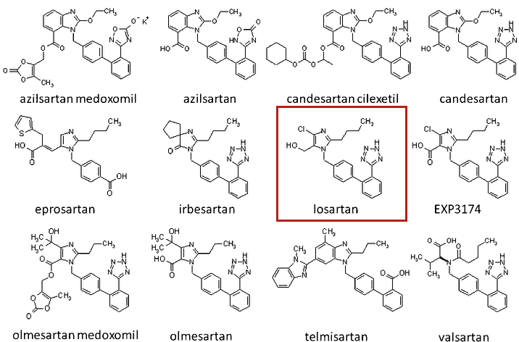
Figure: Molecular structure of Losartan (src: PMID 17043154)

Section 3: Mechanism of action i.e. inhibits viral entry, replication, etc (w/ a pointer to data)

PMID | Chemical (ID) | Gene (ID) | Interaction | InteractionActions
17330452 | Losartan (MESH:D019808) | TGFB1 (7040) | Losartan results in decreased secretion of TGFB1 protein | decreases^secretion
19183357  21047287  21166975 | Losartan (MESH:D019808) | AGT (183) | Losartan results in decreased susceptibility to AGT protein modified form | decreases^response to substance
19587147 | Losartan (MESH:D019808) | SLC2A9 (56606) | Losartan inhibits the reaction [SLC2A9 protein results in increased uptake of Uric Acid] | decreases^reaction, increases^uptake
22982071 | Losartan (MESH:D019808) | AGT (183) | Losartan inhibits the reaction [Ethanol results in increased secretion of AGT protein alternative form] | decreases^reaction, increases^secretion
29859236 | Losartan (MESH:D019808) | RELA (5970) | Losartan inhibits the reaction [Diethylnitrosamine results in increased phosphorylation of RELA protein] | decreases^reaction,increases^phosphorylation
15728788 | Losartan (MESH:D019808) | AGT (183) | Losartan inhibits the reaction [Folic Acid results in increased localization of AGT protein] | decreases^reaction, increases^localization
25994031 | Losartan (MESH:D019808) | CYP2C9 (1559) | CYP2C9 gene mutant form inhibits the reaction [CYP2C9 protein results in increased hydroxylation of Losartan] | decreases^reaction, increases^hydroxylation
28578904 | Losartan (MESH:D019808) | AGT (183) | ICG 001 promotes the reaction [Losartan inhibits the reaction | decreases^reaction, increases^expression, increases^reaction
25398788 | Losartan (MESH:D019808) | AGT (183) | Losartan inhibits the reaction [AGT protein results in increased cleavage of SREBF1 protein] | decreases^reaction, increases^cleavage
15681704  16894058  18800454 | Losartan (MESH:D019808) | AGTR1 (185) | Losartan results in decreased activity of AGTR1 protein | decreases^activity
12084390  9176287  9519251 | Losartan (MESH:D019808) | AGT (183) | Losartan results in decreased activity of AGT protein modified form | decreases^activity
20405111  21321060 | Losartan (MESH:D019808) | CYP2C9 (1559) | CYP2C9 protein affects the metabolism of Losartan | affects^metabolic processing
28578904 | Losartan (MESH:D019808) | CTNNB1 (1499) | Losartan inhibits the reaction [AGT protein results in increased expression of and results in increased activity of CTNNB1 protein] | decreases^reaction, increases^activity, increases^expression
22000973 | Losartan (MESH:D019808) | BCL2 (596) | Losartan affects the expression of BCL2 protein | affects^expression
27470663 | Losartan (MESH:D019808) | ALB (213) | Losartan binds to ALB protein | affects^binding
29859236 | Losartan (MESH:D019808) | GPT (2875) | Losartan inhibits the reaction [Diethylnitrosamine results in increased activity of GPT protein] | decreases^reaction, increases^activity
21127344 | Losartan (MESH:D019808) | AGT (183) | Losartan affects the activity of AGT protein | affects^activity

Section 4: Was the drug identified by manual or computation screen?
Yes.
Disease | Cardiovascular disease
PMID, PMCID | Evidence Sentences
19513641  PMC7122359 | Pharmacophore models have also been used for virtual screening approaches to identify nonpeptidic ligands for peptide-binding GPCRs such as the somatostatin receptor known for its poor bioavailability and low metabolic stability

Section 5: Who is studying the drug? (Source/lab name)

Researcher | Affiliation
Robert L Kruse | Division of Transfusion Medicine, Department of Pathology, Johns Hopkins University School of Medicine, Baltimore, MD.
Hua-Hao Fan | Beijing Advanced Innovation Center for Soft Matter Science and Engineering, College of Life Science and Technology, Beijing University of Chemical Technology, Beijing 100029, China.
Li-Qin Wang | Gansu Provincial Center for Disease Control and Prevention, Lanzhou, Gansu, China.
Wen-Li Liu | 1Department of Dermatology, The First Affiliated Hospital of Xi'an Jiaotong University, Xi'an, 710061 Shaanxi China.
Xiao-Ping An | College of Animal Science, Inner Mongolia Agricultural University, Hohhot, 010018, China.
Zhen-Dong Liu | Key Laboratory of Saline-alkali Vegetation Ecology Restoration, Ministry of Education/Alkali Soil Natural Environmental Science Center, Northeast Forestry University, Harbin 150040, China. liu304418091@126.com.
Xiao-Qi He
Li-Hua Song | School of Agriculture and Biology, Shanghai Jiao Tong University, Shanghai, 200240, People's Republic of China. lihuas@sjtu.edu.cn.
Yi-Gang Tong | Beijing Advanced Innovation Center for Soft Matter Science and Engineering (BAIC-SM), College of Life Science and Technology, Beijing University of Chemical Technology, Beijing, P. R. China.
Pei-Fang Wei
Lewis Taylor | Sir William Dunn School of Pathology, University of Oxford, Oxford, United Kingdom.
Sridhar R Vasudevan | Department of Pharmacology, University of Oxford, Mansfield Road, Oxford, OX1 3QT, UK. Sridhar.vasudevan@pharm.ox.ac.uk.
Chris I Jones | Institute for Cardiovascular and Metabolic Research, School of Biological Sciences, University of Reading, Reading, UK. c.i.jones@reading.ac.uk.
Jonathan M Gibbins | Institute for Cardiovascular and Metabolic Research, University of Reading, Reading, UK.
Grant C Churchill | Department of Pharmacology, University of Oxford, Mansfield Road, Oxford, OX1 3QT, UK.
R Duncan Campbell | Department of Physiology, Anatomy and Genetics, University of Oxford, Le Gros Clark Building, South Parks Road, Oxford, United Kingdom.
Carmen H Coxon | National Institute for Biological Standards and Control Potters Bar UK.
Ingo Ahrens | Department of Cardiology and Medical Intensive Care, Augustinerinnen Hospital, Germany.
Thanigaimalai Pillaiyar | PharmaCenter Bonn, Pharmaceutical Institute, Department of Pharmaceutical and Medicinal Chemistry, University of Bonn, An der Immenburg 4, D-53121 Bonn, Germany.
Sangeetha Meenakshisundaram | Department of Chemistry, Sri Krishna College of Engineering and Technology, Coimbatore, Tamil Nadu, India.
Manoj Manickam | Department of Chemistry, PSG Institute of Technology and Applied Research, Coimbatore, Tamil Nadu, India.
Murugesan Sankaranarayanan | Department of Pharmacy, Birla Institute of Technology and Science Pilani, Pilani Campus, Pilani, 333031, Rajasthan, India.
Jin Soo Shin | Infectious Diseases Therapeutic Research Center, Korea Research Institute of Chemical Technology (KRICT), Daejeon 34114, Korea.
Eunhye Jung | Virus Research Group, Korea Research Institute of Chemical Technology, Daejeon, Republic of Korea.
Meehyein Kim | Infectious Diseases Therapeutic Research Center, Korea Research Institute of Chemical Technology (KRICT), Daejeon 34114, Korea.
Ralph S Baric | Department of Microbiology and Immunology, University of North Carolina School of Medicine, Chapel Hill NC 27599, USA.
Yun Young Go | Virus Research Group, Korea Research Institute of Chemical Technology, Daejeon, Republic of Korea. yygo@krict.re.kr.
Junwen Luan | Institute of Basic Medicine, Shandong Provincial Hospital Affiliated to Shandong First Medical University, Jinan 250062, Shandong, China.
Yue Lu | Department of Epigenetics and Molecular Carcinogenesis, University of Texas M.D. Anderson Cancer Center, Science Park, Smithville, TX, 78957, USA.
Xiaolu Jin | Institute of Basic Medicine, Shandong Provincial Hospital Affiliated to Shandong First Medical University, Jinan, Shandong, China.
Leiliang Zhang | Institute of Basic Medicine, Shandong Provincial Hospital Affiliated to Shandong First Medical University, Jinan 250062, Shandong, China. Electronic address: armzhang@hotmail.com.
Renhong Yan | Key Laboratory of Structural Biology of Zhejiang Province, School of Life Sciences, Westlake University, Hangzhou, China.
Yuanyuan Zhang | College of Pharmacy, Shandong University of Traditional Chinese Medicine, Jinan, China.
Yaning Li | State Key Laboratory of Satellite Navigation System and Equipment Technology, Shijiazhuang 050081, China.
Lu Xia | Shanghai Public Health Clinical Center, Fudan University, Shanghai, People's Republic of China.
Yingying Guo | Department of Cardiothoracic Surgery, The Affiliated Hospital of Jiangnan University, Wuxi, Jiangsu, China.
Qiang Zhou | Department of Molecular and Cell Biology, University of California, Berkeley, CA 94720, USA.
Elizabeth A Nelson | Department of Medical Education, Dell Medical School, University of Texas at Austin, Austin, Texas, USA.
Julie Dyall | Integrated Research Facility, National Institute of Allergy and Infectious Diseases, National Institutes of Health, Frederick, MD, 21702, USA. dyallj@niaid.nih.gov.
Thomas Hoenen | Institute of Molecular Virology and Cell Biology, Friedrich-Loeffler-Institut, Greifswald - Insel Riems, Germany.
Alyson B Barnes | Department of Cell Biology, University of Virginia, Charlottesville, Virginia, United States of America.
Huanying Zhou | Tianjin Key Laboratory of Risk Assessment and Control Technology for Environment and Food Safety, Tianjin Institute of Environmental and Operational Medicine, Tianjin 300050, China.
Janie Y Liang | Integrated Research Facility, Division of Clinical Research, National Institute of Allergy and Infectious Diseases, National Institutes of Health, Frederick, Maryland, United States of America.
Julia Michelotti | Integrated Research Facility, Frederick, Maryland.
William H Dewey | Integrated Research Facility, Division of Clinical Research, National Institute of Allergy and Infectious Diseases, National Institutes of Health, Frederick, Maryland, United States of America.
Lisa Evans DeWald | Emergent BioSolutions, Gaithersburg, Maryland.
Richard S Bennett | Integrated Research Facility, Division of Clinical Research, National Institute of Allergy and Infectious Diseases, National Institutes of Health, Research Plaza, Frederick, Maryland, United States of America.
Patrick J Morris | Division of Preclinical Innovation, National Center for Advancing Translational Sciences, National Institutes of Health, Rockville, MD 20850, USA.
Rajarshi Guha | Division of Preclinical Innovation, National Center for Advancing Translational Sciences, National Institutes of Health, Rockville, Maryland, United States.
Carleen Klumpp-Thomas | National Center for Advancing Translational Sciences, 9800 Medical Center Drive, Rockville, MD, 20850.
Crystal McKnight | Division of Preclinical Innovation, National Center for Advancing Translational Sciences, National Institutes of Health, Rockville, MD 20850, USA.
Yu-Chi Chen | Institute of Clinical Nursing, School of Nursing, National Yang-Ming University, Taipei, Taiwan.
Xin Xu | Henan Provincial Engineering Laboratory of Insects Bio-reactor, Henan Provincial Engineering and Technology Center of Health Products for Livestock and Poultry, Henan Provincial Engineering and Technology Center of Animal Disease Diagnosis and Integrated Control, Nanyang Normal University, Nanyang, 473061, PR China.
Amy Wang | Predicine, Inc., Hayward, CA, United States.
Emma Hughes | Department of Bioengineering and Therapeutic Sciences, University of California San Francisco, San Francisco, California, USA.
Scott Martin | DMPK/ADME Research and Early Development, Oncology R&D, AstraZeneca, Cambridge, UK.
Craig Thomas | Research Institute for Sport and Exercise Sciences (RISES), Liverpool John Moores University, Tom Reilly Building, Byrom St. Campus, Liverpool, L3 3AF, UK.
Peter B Jahrling | Integrated Research Facility at Fort Detrick, National Institute of Allergy and Infectious Diseases, National Institutes of Health, Fort Detrick, Frederick, MD, USA.
Lisa E Hensley | Integrated Research Facility, Division of Clinical Research, National Institute of Allergy and Infectious Diseases, National Institutes of Health, Research Plaza, Frederick, Maryland, United States of America.
Gene G Olinger | Integrated Research Facility, Division of Clinical Research, National Institute of Allergy and Infectious Diseases, National Institutes of Health, Frederick, Maryland, United States of America.
Judith M White | Department of Cell Biology, University of Virginia, Charlottesville, Virginia, USA.
Fatah Kashanchi | National Center for Biodefense and Infectious Diseases, George Mason University, Manassas, VA 20110, USA.
Chintan K Gandhi | Division of Neonatal-Perinatal Medicine, Department of Pediatrics, Milton S. Hershey Medical Center, Hershey, PA, USA.
Romel Holmes | Biology, Tuskegee University, Tuskegee, AL, USA.
Ira H Gewolb | College of Human Medicine, Michigan State University, East Lansing, Michigan.
Bruce D Uhal | Department of Physiology, Michigan State University, 3197 Biomedical and Physical Sciences Building, East Lansing, MI, 48824, USA. uhal@msu.edu.
Qihui Wang | CAS Key Laboratory of Pathogenic Microbiology and Immunology, Institute of Microbiology, Chinese Academy of Sciences (CAS), Beijing 100101, China.
Yanfang Zhang | State Key Laboratory of Virology, Wuhan Institute of Virology, Chinese Academy of Sciences, Wuhan, 430071, China.
Lili Wu | Department of Cardiology, Key Laboratory of Cardiovascular Intervention and Regenerative Medicine of Zhejiang Province, Sir Run Run Shaw Hospital, School of Medicine, Zhejiang University, 3 East Qingchun Road, Hangzhou, Zhejiang, 310016, P.R. China.
Sheng Niu | College of Animal Science and Veterinary Medicine, Shanxi Agricultural University, Taigu 030801, China.
Chunli Song | Department of Orthopaedics, Peking University Third Hospital, Beijing, China. schl@bjmu.edu.cn and Beijing Key Laboratory of Spinal Diseases, 49 North Garden Rd Haidian District, Beijing, China.
Zengyuan Zhang | CAS Key Laboratory of Pathogenic Microbiology and Immunology, Institute of Microbiology, Chinese Academy of Sciences, Beijing 100101, China; University of the Chinese Academy of Sciences, Beijing 100049, China.
Guangwen Lu | West China Hospital Emergency Department (WCHED), State Key Laboratory of Biotherapy, West China Hospital, Sichuan University, and Collaborative Innovation Center of Biotherapy, Chengdu, Sichuan 610041, China.
Chengpeng Qiao | CAS Key Laboratory of Microbial Physiological and Metabolic Engineering, Institute of Microbiology, Chinese Academy of Sciences, Beijing 100101, China.
Yu Hu | Department of Pathology, China-Japan Union Hospital, Jilin University, Changchun, Jilin, China.
Kwok-Yung Yuen | Department of Microbiology and State Key Laboratory for Emerging Infectious Diseases, Li Ka Shing Faculty of Medicine, The University of Hong Kong, Hong Kong SAR, People's Republic of China.
Qisheng Wang | Shanghai Synchrotron Radiation Facility, Shanghai Institute of Applied Physics, Chinese Academy of Sciences, Shanghai, China.
Huan Zhou | West China School of Public Health and West China Forth Hospital, Sichuan University, Chengdu, China.
Jinghua Yan | CAS Key Laboratory of Pathogenic Microbiology and Immunology, Institute of Microbiology, Chinese Academy of Sciences (CAS), Beijing 100101, China.
Jianxun Qi | CAS Key Laboratory of Pathogenic Microbiology and Immunology, Institute of Microbiology, Chinese Academy of Sciences (CAS), Beijing 100101, China.
Rui Li | College of Resources and Environmental Science, Northeast Agricultural University, Harbin, 150030, China.
Songlin Qiao | Key Laboratory of Animal Immunology of the Ministry of Agriculture, Henan Provincial Key Laboratory of Animal Immunology, Henan Academy of Agricultural Sciences, Zhengzhou, Henan, China.
Gaiping Zhang | College of Animal Science and Veterinary Medicine, Henan Agricultural University, Zhengzhou, Henan, China lirui860620@sina.com zhanggaip@126.com.
Nicholas E Ingraham | Division of Pulmonary and Critical Care, University of Minnesota, Minneapolis, MN 55455, USA. Electronic address: ingra107@umn.edu.
Abdo G Barakat | Department of Anesthesiology, University of Minnesota, Minneapolis, MN.
Ronald Reilkoff | Department of Medicine, University of Minnesota, Division of Pulmonary and Critical Care, Minneapolis, MN.
Tamara Bezdicek | Department of Pharmacy, Fairview Pharmacy Services, Minneapolis, MN.
Timothy Schacker | Division of Medicine and Infectious Disease, Department of Medicine, University of Minnesota, Minneapolis, MN, USA.
Jeffrey G Chipman | Division of Acute Care Surgery, Department of Surgery, University of Minnesota, Minneapolis, MN, USA.
Christopher J Tignanelli | Institute for Health Informatics, University of Minnesota, Minneapolis, MN 55455, USA; Division of Acute Care Surgery, Department of Surgery, University of Minnesota, Minneapolis, MN 55455, USA.
Michael A Puskarich | Department of Emergency Medicine, Hennepin Healthcare, Minneapolis, MN.
Yanxiao Han | Department of Chemistry, University of Illinois at Chicago, Chicago, Illinois 60607, United States.
Petr Král | Department of Biopharmaceutical Sciences, University of Illinois at Chicago, Chicago, Illinois 60612, United States.
Chaolin Huang | Jin Yin-tan Hospital, Wuhan, China.
Yeming Wang | Department of Pulmonary and Critical Care Medicine, Laboratory of Clinical Microbiology and Infectious Diseases, Center for Respiratory Diseases, National Clinical Research Center of Respiratory Diseases, China-Japan Friendship Hospital, Beijing, China.
Xingwang Li | Department of Anesthesiology, The Second Affiliated Hospital and Yuying Children's Hospital of Wenzhou Medical University, Wenzhou, Zhejiang, 325027, People's Republic of China.
Lili Ren | NHC Key Laboratory of Systems Biology of Pathogens and Christophe Mérieux Laboratory, Institute of Pathogen Biology, Chinese Academy of Medical Sciences (CAMS) & Peking Union Medical College, Beijing, China.
Jianping Zhao | National Center for Natural Products Research, Research Institute of Pharmaceutical Sciences, University of Mississippi, MS, USA.
Yi Hu | Key Laboratory of Mesoscopic Chemistry of MOE, School of Chemistry and Chemical Engineering, Nanjing University, Nanjing, Jiangsu 210023, China. zhongjin@nju.edu.cn.
Li Zhang | Jiangsu Key Laboratory for High Technology Research of TCM Formulae, National and Local Collaborative Engineering Center of Chinese Medicinal Resources Industrialization and Formulae Innovative Medicine and Jiangsu Collaborative Innovation Center of Chinese Medicinal Resources Industrialization, Nanjing University of Chinese Medicine, Nanjing, China.
Guohui Fan | Institute of Clinical Medical Sciences, China-Japan Friendship Hospital, Beijing, China.
Jiuyang Xu | Department of Basic Medical Sciences, Tsinghua University School of Medicine, Beijing, China.
Xiaoying Gu | Department of Epidemiology, Tulane University School of Public Health and Tropical Medicine, New Orleans, LA 70112, USA.
Zhenshun Cheng | Zhongnan Hospital of Wuhan University, Wuhan, China.
Ting Yu | School of Nursing, Tongji Medical College, Huazhong University of Science and Technology, Wuhan, Hubei, China.
Jiaan Xia | From the Department of Pulmonary and Critical Care Medicine, Center of Respiratory Medicine, National Clinical Research Center for Respiratory Diseases (B.C., Yeming Wang, G.F., F.Z., X.G., Z.L., Y.Z., Hui Li, L.S., C.W.), and the Institute of Clinical Medical Sciences (G.F., X.G.), China-Japan Friendship Hospital, the Institute of Respiratory Medicine, Chinese Academy of Medical Sciences (B.C., Yeming Wang, F.Z., Z.L., Y.Z., Hui Li, C.W.), the Clinical and Research Center of Infectious Diseases, Beijing Ditan Hospital, Capital Medical University (Xingwang Li), Peking University Clinical Research Institute, Peking University First Hospital (C.D.), Tsinghua University School of Medicine (Jiuyang Xu), Beijing University of Chinese Medicine (L.S.), NHC Key Laboratory of Systems Biology of Pathogens and Christophe Merieux Laboratory, Institute of Pathogen Biology, Chinese Academy of Medical Sciences (L.G.), and Peking Union Medical College (L.G., C.W.), Beijing, and Jin Yin-tan Hospital, Wuhan (D.W., W.L., Jingli Wang, L.R., B.S., Y.C., M.W., Jiaan Xia, N.C., Jie Xiang, T.Y., T.B., X.X., L.Z., C.L., Y.Y., H.C., Huadong Li, H.H., S.T., F.G., Y.L., Yuan Wei, K.W., K.L., X.Z., X.D., Z.Q., Sixia Lu, X.H., S.R., Shanshan Luo, Jing Wu, Lu Peng, F.C., Lihong Pan, J.Z., C.J., Juan Wang, Xia Liu, S.W., X.W., Q.G., J.H., H.Z., F.Q., C.H., D.Z.) - all in China; Lancaster University, Lancaster (T.J.), and the University of Oxford, Oxford (P.W.H.) - both in the United Kingdom; and the University of Virginia School of Medicine, Charlottesville (F.G.H.).
Yuan Wei | Three Wards of Outpatient Service, Wuhan Jin Yin Tan Hospital, No.1 Yintan Road, Dongxihu District, Wuhan, 433013, Hubei, China. touyuangeng695@163.com.
Wenjuan Wu | Department of Respiratory, The Second Affiliated Hospital of Kunming Medical University, Kunming 650101, Yunnan, China.
Xuelei Xie | From the Department of Pulmonary and Critical Care Medicine, Center of Respiratory Medicine, National Clinical Research Center for Respiratory Diseases (B.C., Yeming Wang, G.F., F.Z., X.G., Z.L., Y.Z., Hui Li, L.S., C.W.), and the Institute of Clinical Medical Sciences (G.F., X.G.), China-Japan Friendship Hospital, the Institute of Respiratory Medicine, Chinese Academy of Medical Sciences (B.C., Yeming Wang, F.Z., Z.L., Y.Z., Hui Li, C.W.), the Clinical and Research Center of Infectious Diseases, Beijing Ditan Hospital, Capital Medical University (Xingwang Li), Peking University Clinical Research Institute, Peking University First Hospital (C.D.), Tsinghua University School of Medicine (Jiuyang Xu), Beijing University of Chinese Medicine (L.S.), NHC Key Laboratory of Systems Biology of Pathogens and Christophe Merieux Laboratory, Institute of Pathogen Biology, Chinese Academy of Medical Sciences (L.G.), and Peking Union Medical College (L.G., C.W.), Beijing, and Jin Yin-tan Hospital, Wuhan (D.W., W.L., Jingli Wang, L.R., B.S., Y.C., M.W., Jiaan Xia, N.C., Jie Xiang, T.Y., T.B., X.X., L.Z., C.L., Y.Y., H.C., Huadong Li, H.H., S.T., F.G., Y.L., Yuan Wei, K.W., K.L., X.Z., X.D., Z.Q., Sixia Lu, X.H., S.R., Shanshan Luo, Jing Wu, Lu Peng, F.C., Lihong Pan, J.Z., C.J., Juan Wang, Xia Liu, S.W., X.W., Q.G., J.H., H.Z., F.Q., C.H., D.Z.) - all in China; Lancaster University, Lancaster (T.J.), and the University of Oxford, Oxford (P.W.H.) - both in the United Kingdom; and the University of Virginia School of Medicine, Charlottesville (F.G.H.).
Wen Yin | State Key Laboratory of Agricultural Microbiology, College of Life Science and Technology, Huazhong Agricultural University, Wuhan, Hubei 430070, P. R. China.
Hui Li | Center for Proteomics and Metabolomics, State Key Laboratory of Biocontrol, Guangdong Province Key Laboratory for Pharmaceutical Functional Genes, School of Life Sciences, Sun Yat-sen University, University City, Guangzhou, People's Republic of China.
Min Liu | School of Pharmacy, Anhui University of Chinese Medicine, Hefei, China.
Yan Xiao | CAS Key Laboratory on Reservoir Water Environment, Chongqing Institute of Green and Intelligent Technology, Chinese Academy of Sciences; No. 266 Fangzheng Avenue, Shuitu Hi-tech Industrial Park, Shuitu Town, Beibei District, Chongqing 400714, China.
Hong Gao | National Clinical Research Center for Infectious Diseases, Shenzhen Third People's Hospital, Southern University of Science and Technology, Shenzhen, People's Republic of China.
Li Guo | Department of Center Laboratory, The Second Affiliated Hospital of Jiaxing University, Jiaxing, China.
Jungang Xie | Department of Respiratory and Critical Care Medicine, Key Laboratory of Pulmonary Diseases of Health Ministry, Key Cite of National Clinical Research Center for Respiratory Disease, Tongji Hospital, Tongji Medical College Huazhong University of Science and Technology, No. 1095 Jie Fang Avenue, 430030, Wuhan, China.
Guangfa Wang | Department of Respiratory Medicine, Peking University First Hospital, Beijing 100034, People's Republic of China.
Rongmeng Jiang | 1Department of Infectious Disease, Beijing Ditan Hospital, Capital Medical University, No. 8 East Jingshun Street, Chaoyang District, Beijing, 100015 China.
Zhancheng Gao | Dept of Respiratory and Critical Care Medicine, Peking University People's Hospital, Beijing, China zcgao@bjmu.edu.cn.
Qi Jin | School of Pharmaceutical Sciences, Gannan Medical University, Ganzhou, 341000, Jiangxi Province, P. R. China. zhangjiangnmc031@163.com luorenshi2010@163.com.
Jianwei Wang | Department of Pathogen Biology-Microbiology Division, State Key Laboratory of Reproductive Medicine, Key Laboratory of Pathogen Biology of Jiangsu Province, Center for Global Health, Nanjing Medical University , Nanjing, China.
Bin Cao | Tsinghua University-Peking University Joint Center for Life Sciences, Beijing, China.
Paolo Verdecchia | Department of Cardiology, Hospital of Perugia, ITALY.
Claudio Cavallini | Cardiology, Department of Cardiology Ospedale Santa Maria della Misericordia, ITALY.
Antonio Spanevello | Division of Pulmonary Rehabilitation, Istituti Clinici Scientifici Maugeri, IRCCS, Tradate, Italy.
Fabio Angeli | Medicine and Surgery, University of Insubria and Maugeri Care and Research Institute, IRCCS Tradate (VA), ITALY.
Yushun Wan | Department of Veterinary and Biomedical Sciences, College of Veterinary Medicine, University of Minnesota, Saint Paul, MN 55108.
Jian Shang | Department of Veterinary and Biomedical Sciences, College of Veterinary Medicine, University of Minnesota, Saint Paul, MN 55108.
Rachel Graham | Department of Epidemiology, University of North Carolina, Chapel Hill, North Carolina, USA.
Ralph S Baric | Department of Microbiology and Immunology, University of North Carolina School of Medicine, Chapel Hill NC 27599, USA.
Fang Li | Key Laboratory of New Materials and Facilities for Rural Renewable Energy Ministry of Agriculture, Henan Agricultural University, Zhengzhou, China.
Tom Gallagher | Department of Microbiology and Immunology, Loyola University Chicago, Maywood, IL 60153, USA. Electronic address: tgallag@luc.edu.
Wanbo Tai | Laboratory of Viral Immunology, Lindsley F. Kimball Research Institute, New York Blood Center, New York, NY 10065, USA.
Lei He | The Key Lab of Animal Disease and Public Health, Henan University of Science and Technology, 263 Kaiyuan Avenue, Luoyang, 471023, Henan, China.
Xiujuan Zhang | Department of Endocrinology, Shandong Provincial Hospital Affiliated to Shandong University, Jinan, Shandong, China.
Jing Pu | Key Laboratory of Medical Molecular Virology (MOE/NHC/CAMS), School of Basic Medical Sciences and Shanghai Public Health Clinical Center, Fudan University, 130 Dong An Rd., Xuhui District, Shanghai 200032, China.
Denis Voronin | Lindsley F. Kimball Research Institute, New York Blood Center, New York, NY, USA.
Shibo Jiang | Key Laboratory of Medical Molecular Virology (MOE/NHC/CAMS), School of Basic Medical Sciences and Shanghai Public Health Clinical Center, Fudan University, 130 Dong An Rd., Xuhui District, Shanghai 200032, China. lul@fudan.edu.cn shibojiang@fudan.edu.cn qinchuan@pumc.edu.cn.
Yusen Zhou | State Key Laboratory of Pathogen and Biosecurity, Beijing Institute of Microbiology and Epidemiology, Beijing, China.
Lanying Du | Laboratory of Viral Immunology, Lindsley F. Kimball Research Institute, New York Blood Center, New York, NY 10065, USA.
Muthiah Vaduganathan | Brigham and Women's Hospital Heart and Vascular Center, Department of Medicine, Harvard Medical School, Boston, MA.
Orly Vardeny | University of Minnesota, Minneapolis, MN, USA.
Thomas Michel | Division of Cardiovascular Medicine, Department of Medicine, Brigham and Women's Hospital, Harvard Medical School, Boston, MA, USA.
John JV McMurray
Marc A Pfeffer | Cardiovascular Division, Department of Medicine, Brigham and Women's Hospital, Harvard Medical School, Boston, Massachusetts, US.
Scott D Solomon | Brigham and Women's Hospital, Boston, MA (S.D.S.).
Yun Chen | Institute of Biotechnology, State Key Laboratory of Rice Biology, Key Laboratory of Molecular Biology of Crop Pathogens and Insects, Zhejiang University, Hangzhou, 310058, China.
Yao Guo | Nursing College of Henan University of Chinese Medicine, Zhengzhou, Henan, China.
Yihang Pan | Tomas Lindahl Nobel Laureate Laboratory, the Seventh Affiliated Hospital of Sun Yat-sen University, Shenzhen, Guangdong, 518107, P. R. China.
Zhizhuang Joe Zhao | Edmond H. Fischer Signal Transduction Laboratory, College of Life Sciences, Jilin University, Changchun, China. joe-zhao@ouhsc.edu.
Giovanni de Simone | Hypertension Research Center and Department of Advanced Biomedical Sciences, Federico II University of Naples, Italy.
Costantino Mancusi | Hypertension Research Center and Department of Advanced Biomedical Sciences, Federico II University of Naples, Italy.
Su-Xia Han | Department of Cardiovascular Medicine, Shanghai Pudong New Area People's Hospital Affiliated to Shanghai Health University, Shanghai, China.
Guang-Ming He | Department of Pharmacy, Peking University Shenzhen Hospital, Shenzhen 518035, China.
Tao Wang | Key Laboratory of Advanced Manufacturing and Intelligent Technology, Ministry of Education, Harbin, China.
Lei Chen | Department of Neurosurgery, Wuxi Clinical College of Anhui Medical University, 904 Hospital of Joint Logistic Support Force of PLA, Wuxi, Jiangsu Province, China.
Yun-Ye Ning | 1 Department of Respiratory and Critical Care Medicine, Changhai Hospital, Second Military Medical University, Shanghai, P.R. China.
Feng Luo | Shenzhen University, Shenzhen, Guangdong, CHINA.
Jin An | Department of Allergy and Clinical Immunology, Airway Sensation and Cough Research Laboratory, Asan Medical Center, University of Ulsan College of Medicine, Seoul, Korea.
Ting Yang | Children's Nutrition Research Center, Children's Hospital of Chongqing Medical University, Chongqing Key Laboratory of Child Nutrition and Health, Ministry of Education Key Laboratory of Child Development and Disorders, National Clinical Research Center for Child Health and Disorder, China International Science and Technology Cooperation Base of Child Development and Critical Disorders, Chongqing, China.
Jia-Jia Dong | Department of Ultrasonography, the First Affiliated Hospital of Wenzhou Medical University, Wenzhou, China.
Zeng-lin Liao
Dan Xu | Department of Radiology, Zhongnan Hospital of Wuhan University, Wuchang District, Wuhan, China.
Fu-Qiang Wen | Department of Respiratory and Critical Care Medicine, West China Hospital of Sichuan University, and Division of Pulmonary Diseases, State Key Laboratory of Biotherapy of China, Chengdu 610041, China.
Markus Hoffmann | Deutsches Primatenzentrum-Leibniz Institute for Primate Research, Göttingen, Germany.
Hannah Kleine-Weber | Deutsches Primatenzentrum-Leibniz Institute for Primate Research, Göttingen, Germany.
Simon Schroeder | Charité-Universitätsmedizin Berlin, corporate member of Freie Universität Berlin, Humboldt-Universität zu Berlin, and Berlin Institute of Health, Institute of Virology, Berlin, Germany.
Nadine Krüger | Institute of Virology, University of Veterinary Medicine Hannover, Hannover, Germany; Research Center for Emerging Infections and Zoonoses, University of Veterinary Medicine Hannover, Hannover, Germany.
Tanja Herrler | Department of Hand Surgery, Trauma Center Murnau, Murnau, Germany.
Sandra Erichsen | Institute for Biomechanics, BG Unfallklinik Murnau, Murnau, Germany; Institute for Biomechanics, Paracelsus Medical University Salzburg, Salzburg, Austria.
Tobias S Schiergens | Department of General, Visceral, and Transplant Surgery, Ludwig-Maximilians-University Munich, Munich, Germany.
Georg Herrler | Institute of Virology, University of Veterinary Medicine Hannover, 30559 Hannover, Germany.
Nai-Huei Wu | Institute of Virology, University of Veterinary Medicine Hannover, 30559 Hannover, Germany.
Andreas Nitsche | Centre for Biological Threats and Special Pathogens 1 - Highly Pathogenic Viruses & German Consultant Laboratory for Poxviruses & WHO Collaborating Centre for Emerging Infections and Biological Threats, Robert Koch Institute, Berlin, Germany.
Marcel A Müller | Charité-Universitätsmedizin Berlin, corporate member of Freie Universität Berlin, Humboldt-Universität zu Berlin, and Berlin Institute of Health, Institute of Virology, Berlin, Germany.
Christian Drosten | Charité-Universitätsmedizin Berlin, corporate member of Freie Universität Berlin, Humboldt-Universität zu Berlin, and Berlin Institute of Health, Institute of Virology, Berlin, Germany.
Stefan Pöhlmann | Deutsches Primatenzentrum-Leibniz Institute for Primate Research, Göttingen, Germany spoehlmann@dpz.eu.
K Abraham Peele | Department of Bio-Technology, Vignan's Foundation for Science, Technology & Research, Guntur, Andhra Pradesh, India.
P Chandrasai | Department of Bio-Technology, National Institute of Technology, Warangal, 506004, Telangana, India.
T Srihansa | Department of Bio-Technology, Vignan's Foundation for Science, Technology & Research, Guntur, Andhra Pradesh, India.
S Krupanidhi | Department of Bio-Technology, Vignan's Foundation for Science, Technology & Research, Guntur, Andhra Pradesh, India.
A Vijaya Sai | Department of Bio-Technology, Vignan's Foundation for Science, Technology & Research, Guntur, Andhra Pradesh, India.
D John Babu | Department of Bio-Technology, Vignan's Foundation for Science, Technology & Research, Vadlamudi, 522213, Andhra Pradesh, India.
M Indira | Department of Bio-Technology, Vignan's Foundation for Science, Technology & Research, Vadlamudi, 522213, Andhra Pradesh, India.
A Ranganadha Reddy | Department of Bio-Technology, Vignan's Foundation for Science, Technology & Research, Vadlamudi, 522213, Andhra Pradesh, India.
TC Venkateswarulu
David Gurwitz | Department of Human Molecular Genetics and Biochemistry, Sackler Faculty of Medicine, Tel Aviv, Israel.
Hongliang Wang | Animal Husbandry and Veterinary Institute, Heilongjiang Academy of Land Reclamation Sciences, Harbin, China.
Shuan Rao | Department of Thoracic surgery, Nanfang Hospital.
Chengyu Jiang | State Key Laboratory of Medical Molecular Biology, Institute of Basic Medical Sciences, Chinese Academy of Medical Sciences, Department of Biochemistry, Peking Union Medical College, Beijing, China. Electronic address: jiang@pumc.edu.cn.

Section 6: In vitro Data available (cell line used, assays run, viral strain used, cytopathic effects, toxicity, LD50, dosage response curve, etc)
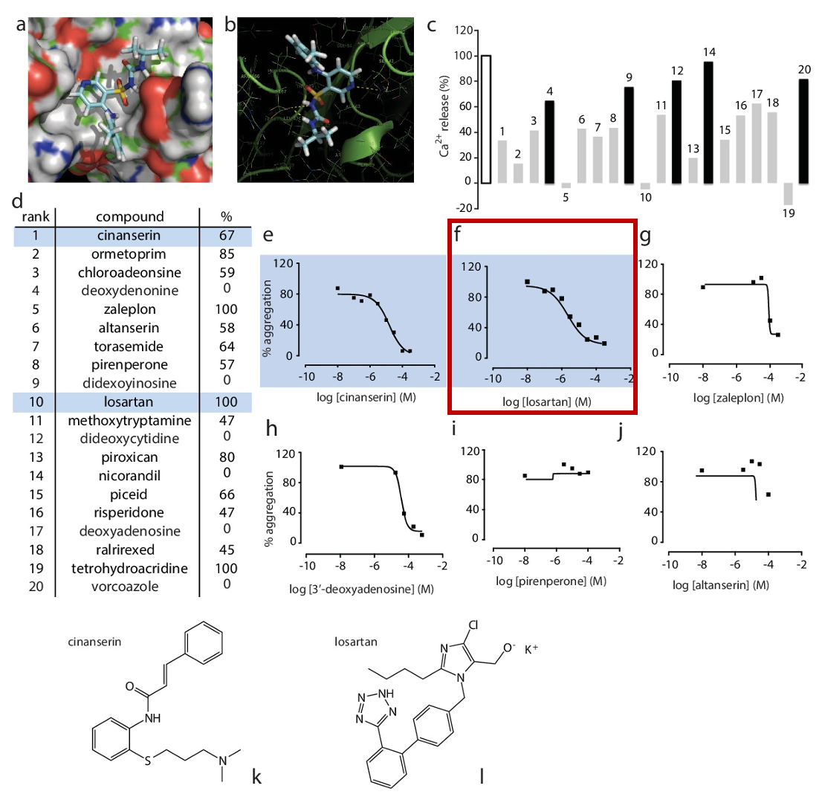
Src: PMC4074120 Fig. 1. In silico identifies GPVI antagonist. Representative image capture of in silico docking into GPVI using Glide, with space filling model is shown in a, and H-bonding to relevant side chains is detailed in b. The 20 highest ranking compounds were screened for effects on Ca2+ release by the GPVI-specific agonist CRP-XL (10 mg/ml) (c and d, % refers to percent inhibition of Ca2+ release). Maximum Ca2+ release is shown in white, compounds that inhibited Ca2+ release by , 50% or more are in grey, and the remainder in black. Commercially available compounds that inhibited CRP-XL-induced Ca2+ release .50% were further screened by light transmission aggregometry to identify compounds displaying dose-dependent inhibition (e-j). Examples are shown of weak antagonism (g and h) and false positives (i and j). Cinanserin (l) and losartan (k) were taken on for further study.
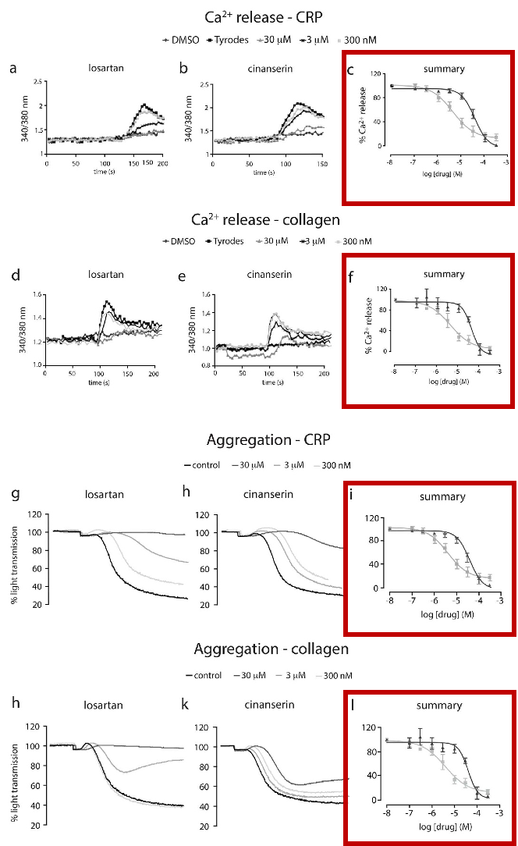
Src: PMC4074120 Fig. 2. Losartan and cinanserin inhibit GPVI-mediated cell activation. Washed human platelets were loaded with fura2-AM and screened for drug-mediated inhibition of Ca2+ release by 1 mg/ml CRP-XL (n = 3, 6 SEM, representative traces and summary, a–c) and 1 mg/ml collagen (n = 3, SEM, representative traces and summary, d–f); losartan (&) and cinanserin (m). To measure aggregation, washed human platelets were incubated with drug for one minute prior to the addition of 1 mg/ml CRP-XL (representative traces and summary shown in g–i) or 1 mg/ml collagen (representative traces and summary shown in j–l).
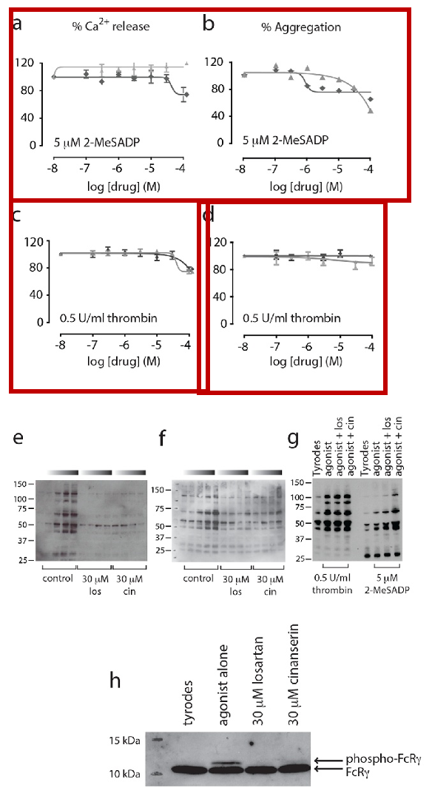
Src: PMC4074120 Fig. 3. Losartan and cinanserin demonstrate selectivity for GPVI. Ca2+ release and aggregations were carried out with 5 mM of the P2Y12 receptor agonist 2-MeSADP (a, Ca2+ release and b, aggregation), or 0.5 U/ml of the PAR1 and PAR4 receptor agonist thrombin (c, Ca2+ release and d, aggregation). Losartan (X); cinanserin (m), n = 3, 6 SEM. For global tyrosine phosphorylation, washed human platelets were incubated with drug or vehicle alone before addition of 1 mg/ml CRP-XL or collagen. Samples were collected at 10, 30, 60 or 90 seconds (as indicated by the graduated bars with time increasing to the right) in ice cold 26 lysis buffer and separated on 4–12% NuPage gels under reducing conditions. Tyrosine phosphorylation was visualized with 4G10 anti-phosphotyrosine antibody. Losartan and cinanserin reduce CRP-XL- (e) and collagen-(f) induced global tyrosine phosphorylation, but have no effect on thrombin or 2-MeSADP induced global tyrosine phosphorylation (g). Both drugs reduce FcRc phosphorylation (h), (unphosphorylated, lower band; phosphorylated, upper band).
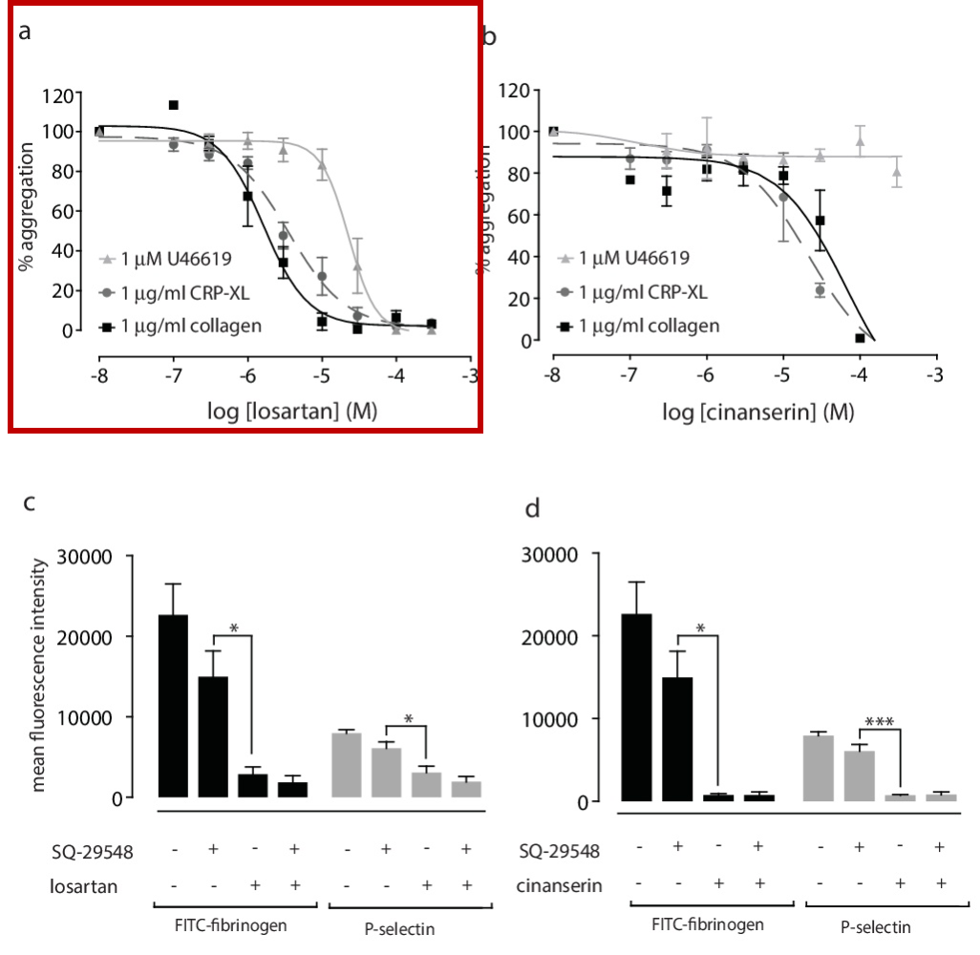
Src: PMC4074120 Fig. 4. Losartan is selective for GPVI over TPR. To assess effects on TPR signalling, platelets were activated with 1 mM U46619 and aggregations followed for 5 minutes in the presence of or absence of drug (n = 3, 6 SEM). Collagen (solid black line) and CRP-XL (dashed dark grey line) were both used at 1 mg/ml. Losartan (a) has an IC50 of , 20 mM for U46619-induced aggregation (solid grey line) while cinanserin (b) has no effect on TPR signaling (solid grey bar). Exposure of P-selectin (CD62P) and FITC-fibrinogen binding was measured by flow cytometry. Losartan (100 mM, c) and cinanserin (100 mM, d) both reduce FITC-fibrinogen binding (black bars) and P-selectin exposure (grey bars) compared to SQ-29548 alone. Statistical analysis was conducted by one-way ANOVA with Sidak’s multiple comparisons correction. ns P.0.05, * P, 0.05, *** P, 0.001, n = 3, 6 SEM.
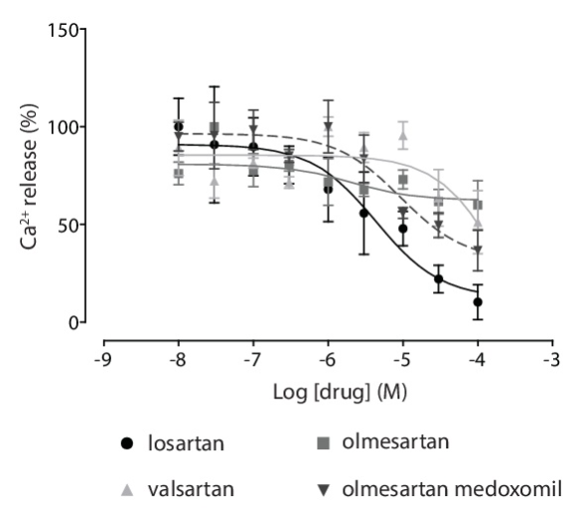
Src: PMC4074120 Fig. 6. GPVI antagonism is unique to losartan amongst the sartan drug class. Inhibition of collagen-induced Ca2+ release (10 mg/ ml) the sartans from fura2-AM-loaded washed human platelets was measured and quantified (n = 3, 6 SEM).
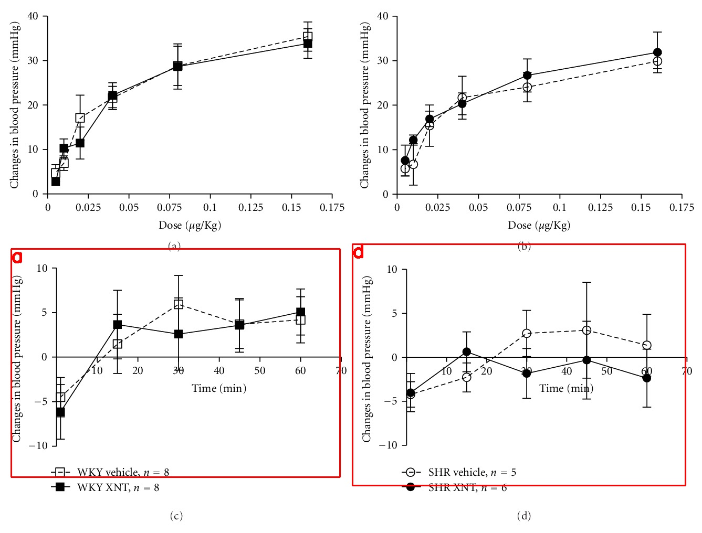
Src: PMC3270559 Fig 2: Effects of Ang II and Losartan on arterial blood pressure of rats chronically treated with XNT. The responses to increasing doses of Ang II were similar in vehicle- and XNT-treated (a) normotensive (Wistar-Kyoto rats—WKY) and (b) hypertensive (spontaneously hypertensive rats—SHR) rats. Likewise, the response to Losartan (0.25 mg/kg) was similar in vehicle- and XNT-treated (c) normotensive (WKY) and (d) hypertensive (SHRs) rats. The blood pressure was measured through a catheter inserted into the carotid artery and Ang II and Losartan were administrated in bolus using the jugular vein.
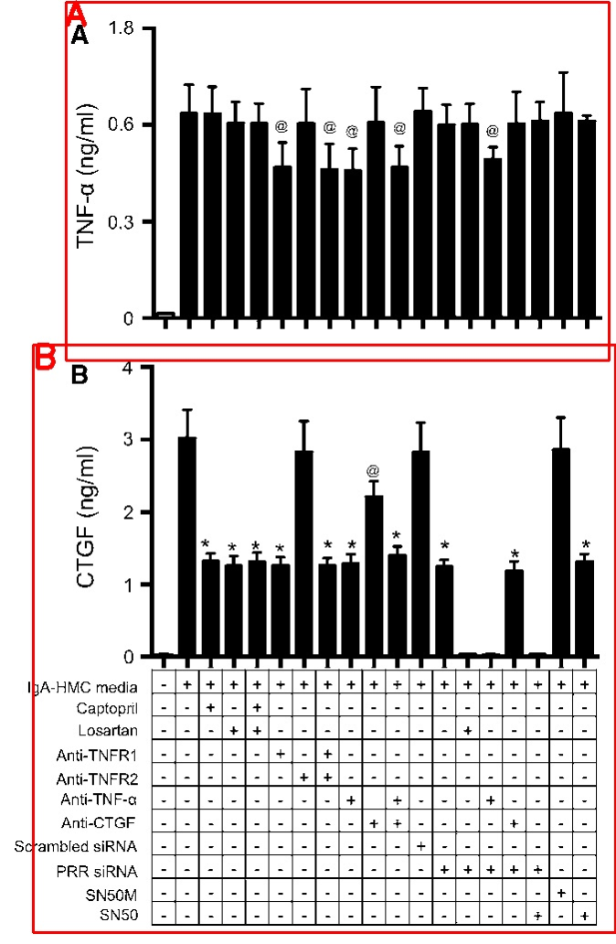
Src: PMC7101871 Fig. 4 Effect of blockade of RAS, NFjB, or TNF-a receptors on TNF-a or CTGF release by podocytes cultured with IgA-HMC media. Effects of combination blockade on podocytic (a) TNF-a, or (b) CTGF release following incubation with eightfold diluted IgA- HMC media. @ or * signifies p \ 0.05 or p \ 0.01 versus podocytes incubated with IgA-HMC media without intervention. The results represent the mean ± standard deviation from five individual ex- periments. Captopril: ACE inhibitor; Losartan: angiotensin II receptor antagonist; SN50: peptide inhibits the translocation of the active NF- jB complex into the nucleus; SN50M: control peptide for SN50.
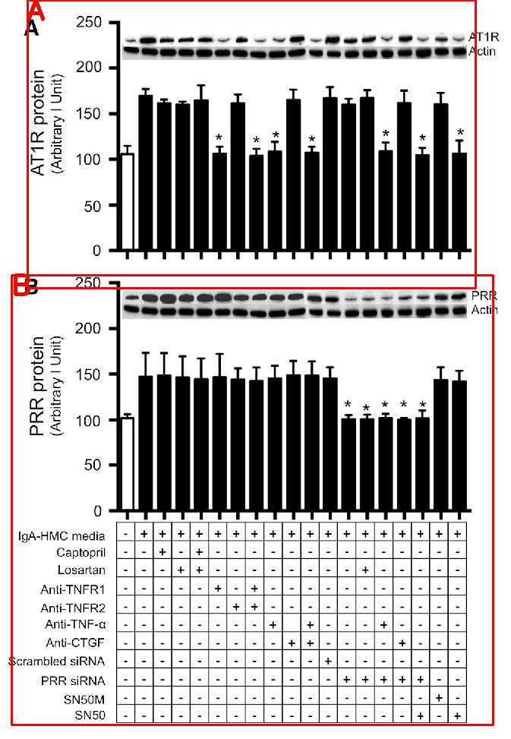
Src: PMC7101871 Fig. 5 Effects of combination blockade on podocytic AT1R or PRR expression following incubation with IgA-HMC media. Effects of combination blockade on podocytic expression of (a) AT1R, or (b) PRR following incubation with eightfold diluted IgA-HMC media. @ or * signifies p\0.05 or p\0.01 versus podocytes incubated with IgA-HMC media without intervention. The results represent the mean ± standard deviation from five individual ex- periments. Captopril: ACE inhibitor; Losartan: angiotensin II receptor antagonist; SN50: peptide inhibits the translocation of the active NF- jB complex into the nucleus; SN50M: control peptide for SN50
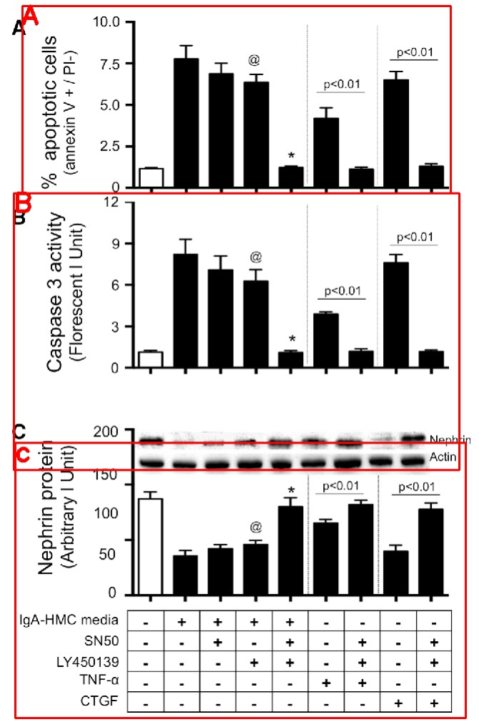
Src: PMC7101871 Fig. 6. Effects of combination block adeonpodocy ticcaspase 3 activity and nephrin expression following incubation with IgA-HMC media. Effects of combination blockade on podocytic (a) caspase 3 activity, (b) % apoptosis cells, or (c) nephrin expression following incubation with eightfold diluted IgA-HMC media. Blockade of AT1R, TNFR1, NFjB, PRR, TNF-a or CTGF neutralization partially ameliorated the up- regulated caspase 3 activity, apoptotic cell number and reduced nephrin expression. Complete abolishment was achieved by simultaneous TNF-a and CTGF neutralization or PRR blockade together with blockade of AT1R, NFjB inhibition, or TNF-a neutralization. The results represent the mean ± standard deviation from five individual experiments. Captopril: ACE inhibitor; Losartan: angiotensin II receptor antagonist; SN50: peptide inhibits the translocation of the active NF-jB complex into the nucleus; SN50M: control peptide for SN50
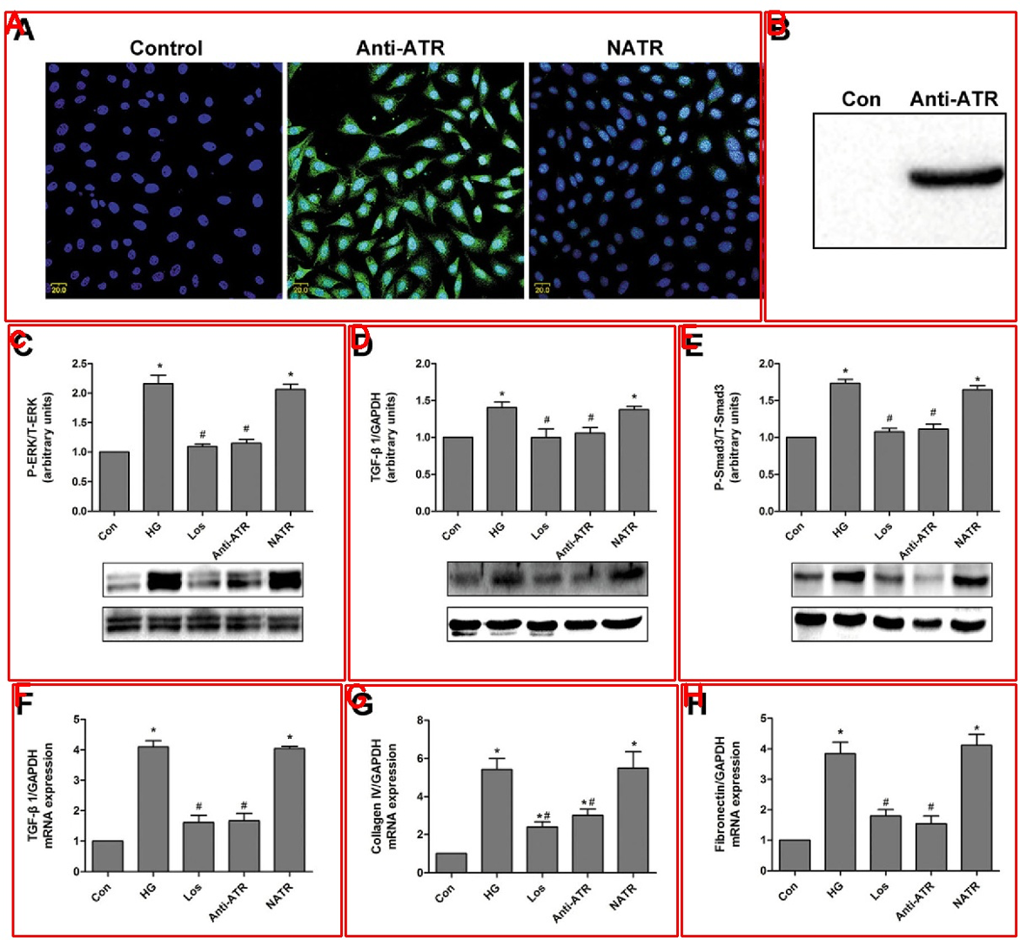
Src: PMC4762923 Fig. 6 Anti-ATR-001 inhibited the TGF-β1/Smad3 signal pathway and expression of collagen IV and fibronectin in rat mesangial cells. As shown on a and b, anti-ATR-001 specifically bound to AT1R in rat mesangial cells (RMCs). Representative Western blots (lower panel) showing specific bands for c P-ERK1/2, d TGF-β1, e Smad3, and quantitative analysis were presented on upper panel. The relative expression of TGF-β1 and collagen I and IV mRNA were shown on f, g, and h. Con control, HG high glucose (25 mmol/l), Los losartan treatment, Anti-ATR anti-ATR-001 treatment, NATR anti-NATR-001 treatment (n=5). *P<0.05 vs. con; #P<0.05 vs. HG

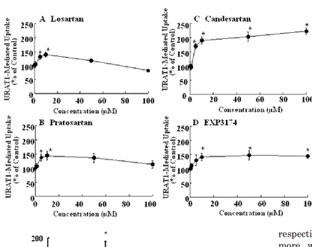
Src: PMID 17043154 Fig. 3. Concentration dependence of trans-stimulatory ef- fects of preloaded ARBs on URAT1-mediated uptake by URAT1-expressing oocytes. Aliquots of 50 nl of losartan (A), pratosartan (B), candesartan (C), and EXP3174 (D) solutions at various concentrations from 1 to 100 􏰊M were preloaded, and uptake of [14C]uric acid (20 􏰊M) was mea- sured for 15 min. The URAT1-mediated uptake was deter- mined by subtracting the uptake by water-injected oocytes from that by URAT1-cRNA-injected oocytes, and the values obtained were divided by the control value in each assay. ARBs were dissolved with water containing 0.1% DMSO and adjusted to pH 7.4 with KOH. Each point represents the mean 􏰇 S.E. from 10 oocytes from one individual ex- periment. 􏰌, significant difference from the control (no in- hibitor) by Dunnett’s test (p 􏰈 0.05).

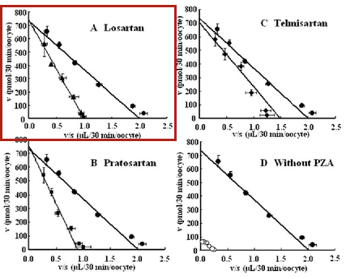

Src: PMID 17043154 Fig. 6. Kinetic analysis of inhibitory effect of ARBs on uptake of uric acid by URAT1 expressed in oocytes pre- loaded with PZA. The uptakes of [14C]uric acid (20, 50, 200, 500, 1000, and 2000 􏰊M) by water-injected or URAT1- cRNA-injected oocytes were measured in the absence (con- trol; closed circles) or presence of 10 nM losartan (A; closed triangle), pratosartan (B; closed diamonds), and telmisar- tan (C; closed squares) of them for 30 min after preload of PZA by microinjection (100 mM 􏰆 50 nl, 5 nmol). The uptake of [14C]uric acid by oocyte was measured after pre- load of PZA (closed circles) by microinjection (100 mM 􏰆 50 nl, 5 nmol) or with Cl􏰉 (open circles) by preincubation with ND96 buffer for 15 min (D). URAT1-mediated uptakes were determined by subtracting the uptake by water-in- jected oocytes from that by URAT1-cRNA-injected oocytes and are shown by Eadie-Hofstee plot analysis. ARBs were dissolved in uptake buffer containing 0.1% DMSO. Each point represents the mean 􏰇 S.E. from 10 oocytes from one individual experiment.

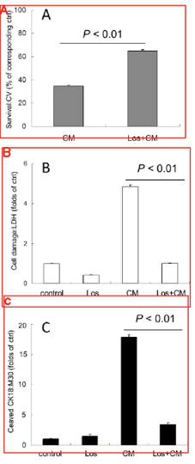
Src: PMC7095783 Fig. 5. Losartan attenuated cytomix-induced cytotoxicity in A549 cells. A549 was pretreated with losartan (Los: 0.5 mM) 1 h before cytomix (CM: a mixture of IL- 1β/TNF-α/IFN-γ) stimulation. Forty eight hours after cytomix stimulation, cytotoxicity was evaluated as described in "Materials and Methods". Control cells were treated with the corresponding vehicle alone. Bar graph shows means ± S.E.M. (A) Losartan significantly recovered cell number in A549 cells stimulated with cytomix in crystal violet staining. (B and C) LDH and cleaved cytokeratin 18 in culture medium were also determined. Losartan significantly decreased LDH (B) and cleaved cytokeratin 18 levels (C) in A549 cells stimulated with cytomix.

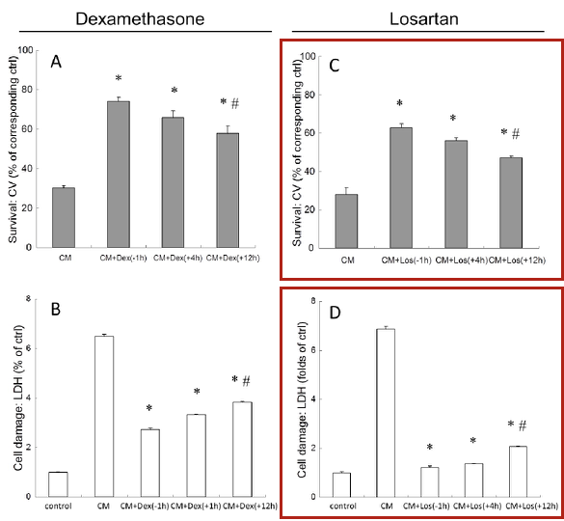
Src: PMC7095783 Fig. 7. Dexamethasone or losartan still exerted cytoprotection with delayed treatment after cytomix challenge in A549 cells. A549 was stimulated with cytomix (CM: a mixture of IL-1β/TNF-α/IFN-γ). Co-treatement of either dexamethasone (1 μM or losartan (0.5 mM) was initiated 1 h before (−1 h), 4 h after (+4 h), or 12 h after (+12 h) cytomix stimulation. Sixty hours after cytomix stimulation, cytotoxicity was evaluated by crystal violet staining and LDH measurement. Dexamethasone (A and B) or losartan (C and D) still conferred cytoprotection significantly with delayed treatment up to 12 h after cytomix challenge, although the degree of cytoprotection decreased significantly compared to pretreatment (−1 h). Control (ctrl) cells were treated with the corresponding vehicle alone. Bar graph shows means ± S.E.M. * p < 0.01 vs. CM; # p < 0.01 vs. pretreatment (−1 h).

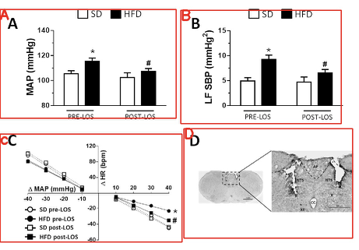
Src: PMC7092339 Fig.2. a Mean arterial pressure (MAP), b low frequency (LF) of the systolic blood pressure (SBP), and c baroreflex function in rats fed either the standard diet (SD) or high-fat diet (HFD) before and after bilateral injections of losartan (LOS; 10 μg/100 nl) into the nucleus of the solitary tract (NTS). d Photomicrograph of a coronal section of the brainstem showing the typical location of the intermediate NTS microinjection sites. AP area postrema, CC central canal, X dorsal motor nucleus of the vagus, XII hypoglossal nucleus. Scale bar = 500 μm. The results are presented as the means ± SEM from the SD (n = 5) and HFD (n = 6) groups. Two-way ANOVA followed by the Student–Newman–Keuls test; *different from the SD group; #different from the HFD pre-LOS group; P < 0.05

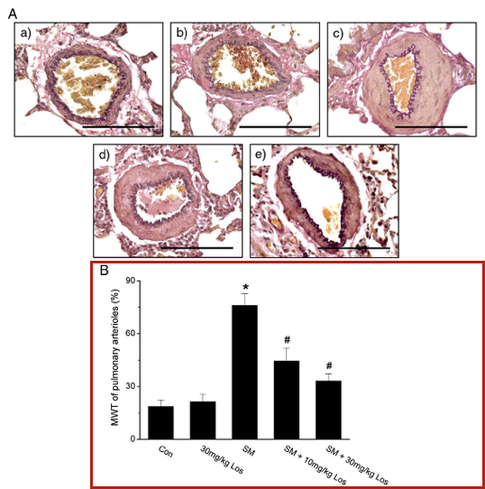
Src: PMC7103128 Fig.1. Light microscopic determinations of pulmonary arterial remodeling in lung sections stained with elastic van Gieson. (A) Representative morphologic images of pulmonary arteries in rats treated with a) control (Con), b) 30 mg/kg losartan-only (30 mg/kg Los), c) smoke-only (SM), d) smoke plus 10 mg/kg losartan (SM + 10 mg/kg Los), and e) smoke plus 30 mg/kg losartan (SM + 30 mg/kg Los). Original magnification, × 60. Scale bars = 100 μm. (B) Medial wall thickness (MWT) of pulmonary arterioles. Values are expressed as mean±SD (n=4–5). ⁎Pb0.05, as compared with the Con group; #Pb0.05, as compared with the SM group.

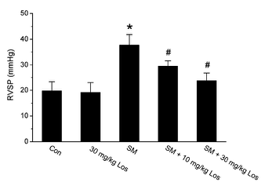
Src: PMC7103128 Fig.2. Losartan inhibits the smoke-induced elevation of right ventricular systolic pressure (RVSP) in rats. Values are expressed as mean±SD (n=4–5). ⁎Pb0.05, as compared with the Con group; #Pb0.05, as compared with the SM group.
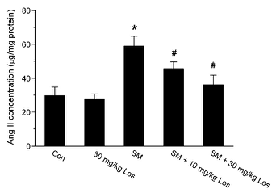
Src: PMC7103128 Fig.3. Losartan reduced smoke-induced Ang II increase in rat lungs. Ang II levels were measured by iodine-125 radioimmunoassay as described in Materials and methods. Values are expressed as mean±SD (n=4–5). ⁎Pb0.05 vs Con; #Pb0.005 vs SM.

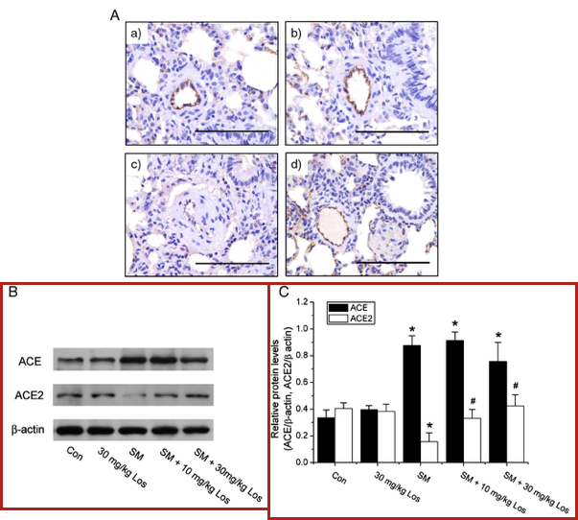
Src: PMC7103128 Fig.4. Measurement of ACE2 and ACE protein levels in rat lungs (n = 4–5). (A) Immunohistochemistry for ACE2 in rat lung sections from a) Con, b) 30 mg/kg Los, c) SM, and d) SM+30mg/kg Los groups (original magnification, ×60). Scale bars=100μm. (B) Western blotting analysis for ACE2 and ACE protein in lung tissue. Images are representative of three independent experiments. (C) Semiquantification of ACE (solid bars) and ACE2 (open bars) levels by densitometry. ⁎P b 0.05, as compared with the Con group; #Pb0.05, as compared with the SM group.

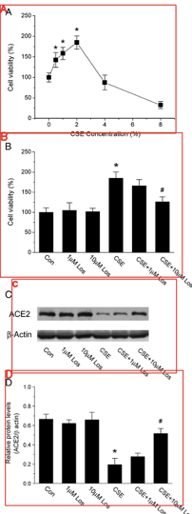
Src: PMC7103128 Fig.6. Inhibitory effect of losartan treatment on cigarette smoke extract (CSE)-induced cell proliferation and ACE2 reduction in rat PASMCs. (A) For determination of cell number by CCK-8, PASMCs were treated with different concentration of CSE (0%, 0.5%, 1%, 2%, 4%, and 8%). Each experimental condition was repeated at least in quintuplicate wells in each experiment. Values are expressed as mean±SD. (B) Inhibitory effect of losartan pretreatment on 2% CSE-induced rat PASMC proliferation. (C) Western blotting analysis for ACE2 in 2% CSE-challenged PASMCs. Images are representative of three independent experiments. (D) Semi-quantification of ACE2 levels by densitometry (ACE2/β-actin ratio). Con: control; Los: losartan; CSE: 2% cigarette smoke extract. ⁎Pb0.05, as compared with the Con; #Pb0.05, as compared with the CSE.

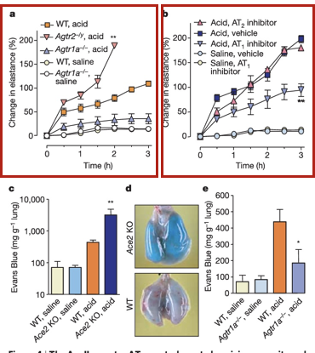
Src: PMC7094998 Fig. 4. The AngII receptor AT1a controls acute lung injury severity and pulmonary vascular permeability. a, Lung elastance measurements in Agtr1a2/2 mice, Agtr22/y mice and WTmice after acid aspiration (n 1⁄4 4–6 per group). All acid-treated Agtr2 2/y mice died after 2 h. There is a significant difference (P , 0.01) between acid-treated WT and acid-treated Agtr1a2/2 mice over the whole time course. Double asterisk denotes a significant difference (P , 0.01) between WT and Agtr22/y mice at 2 h. b, Lung elastance measurements in Ace2 knockout mice treated with vehicle or inhibitors to AT1 (Losartan, 15 mg kg21) or AT2 (PD123.319, 15 mg kg21) after acid or saline instillation (see Methods, n 1⁄4 4–6 per group). Double asterisk denotes a significant difference (P , 0.01) comparing Ace2 knockout mice treated with AT1 inhibitor with vehicle or AT2 inhibitor treatment at 3 h. c, Pulmonary vascular permeability as determined by intravenous injection of Evans Blue. Extravascular Evans Blue in lungs was measured in WT and Ace2 knockout mice 3 h after acid injury (n 1⁄4 5 per group). Double asterisk denotes a significant difference (P , 0.01) between acid-treated WT and Ace2 knockout mice. d, Representative images of Evans Blue-injected lungs of WT and Ace2 knockout mice 3 h after acid aspiration. e, Extravascular Evans Blue in lungs of WTand Agtr1a2/2 mice 3 h after acid injury (n 1⁄4 5 per group). Asterisk denotes a significant difference (P , 0.05) between acid-treated WT and Agtr1a2/2 mice at 3 h. Error bars indicate s.e.m.

Section 7: Animal Data Available (what animal model, LD50, dosage response curve, etc)

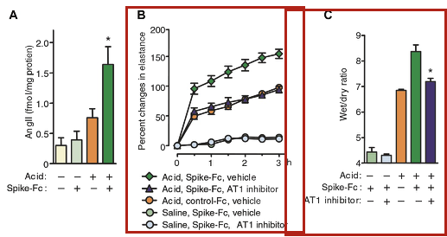
Src: PMC7184165 Fig. 2. SARS-CoV spike mediates lung injury through modulation of angiotensin II in acid aspiration mice. a Lung angiotensin II levels in SARS-CoV-S protein (spike-Fc protein)- or control Fc protein-treated mice after acid or saline aspiration. *P < 0.05 vs. control-treated mice after acid aspiration. b Effects of losartan (15 mg/kg) (AT1 inhibitor) on lung elastance measurements in acid plus spike-Fc protein-treated mice (n = 4–6 per group). P < 0.05 comparing losartan-treated spike- Fc–challenged mice with vehicle-treated spike-Fc–challenged mice. c Effects of losartan (15 mg/kg) on lung edema (wet/dry weight ratio) in acid plus spike-Fc protein-treated mice (n = 4–6 per group). P < 0.05 vs. vehicle-treated wild-type mice after acid injury. AT1, angio- tensin II type-1 receptor. Cited from ref. [27]
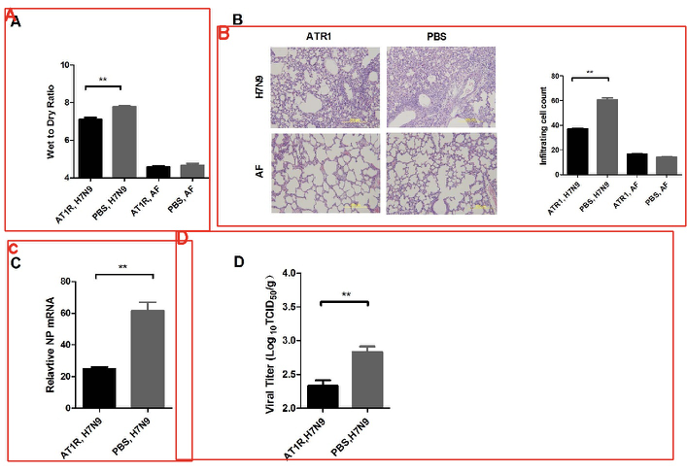
Src: PMC4229671 Fig.3. The Ang II receptor AT1 regulates H7N9-induced lung injury. (A) The wet-to-dry ratio of the lungs of WT mice treated with control or AT1 inhibitor (losartan, 15 mg/kg) 30 min before Hb01/H7N9 virus infection (n 5 8). (B) H&E staining and infiltrating cell counts (n 5 200 fields) in the lung tissue of Hb01/H7N9 influenza virus-infected B6 mice treated with PBS control or AT1 inhibitor (losartan, 15 mg/kg) at day 5 post-infection. (C) Detection of Hb01/H7N9 virus NP RNA in WT mice treated with PBS control or AT1 inhibitor (losartan, 15 mg/kg) 30 min before Hb01/H7N9 virus infection (n 5 8) at day 5 post-infection. NP mRNA expression was quantified using real-time PCR, and was normalized to GAPDH (n 5 10). (D) Lung viral titers in WT mice treated with PBS control or AT1 inhibitor (losartan, 15 mg/kg) before Hb01/H7N9 virus infection (n 5 8) at day 5 post-infection. **p , 0.01(two-tailed t-test).

Disease | SARS-CoV-2
PMID, PMCID | Evidence Sentences
32336612  PMC7167588 | In animal experiments, diets rich of fats decreased ACE2 activity and angiotensin1-7, and increased angiotensin II and blood pressure levels in male, but not in female, animals and these reactions were inhibited by AT1 blockade with losartan.
32341103  PMC7236830 | It is important to note that preclinical animal model treatment with losartan upregulates cardiac ACE2 mRNA expression and increases in ACE2 activity.

Disease | Lung disease
PMID, PMCID | Evidence Sentences
30759273  PMC7088148 | Rosenfeld et al. showed that exposure to meconium induces AT1 receptor expression and further that losartan, an antagonist for the AT1 receptor, attenuates meconium-induced AEC apoptosis in newborn rabbit lung.  Interestingly, previous attempts to downregulate ACE/ANGII/AT1 axis by using captopril and losartan have produced mixed results in human and animal studies.  It is important to note that preclinical animal model treatment with losartan upregulates cardiac ACE2 mRNA expression and increases in ACE2 activity.

Section 8: Clinical trials on going (what phase, facility, target population, dosing, intervention etc)

Disease | COVID-19
PMID, PMCID | Evidence Sentences
32336612  PMC7167588 | Two trials of losartan as additional treatment for SARS-CoV-2 infection in hospitalized (NCT04312009) or not hospitalized (NCT04311177) patients have been announced, supported by the background of the huge adverse impact of the ACE Angiotensin II AT1 receptor axis over-activity in these patients.
32350632  PMC7189178 | To address the role of angiotensin in lung injury, there is an ongoing clinical trial to examine whether losartan treatment affects outcomes in COVID-19 associated ARDS (NCT04312009).
32439915  PMC7242178 | Losartan was also the molecule chosen in two trials recently started in the United States by the University of Minnesota to treat patients with COVID-19 (clinical trials.gov NCT04311177 and NCT 104312009).

Disease | Cardiovascular Disease
PMID, PMCID | Evidence Sentences
32034644  PMC7171054 | At least 17 warnings to date have been listed on the Food and Drug Administration recall website (https://www.fda.gov/safety/recalls-market-withdrawals-safety-alerts). ARBs, such as valsartan and losartan, represent a class of medications that in randomized controlled clinical trials (RCTs) have been shown to reduce blood pressure (BP) in hypertensive patients and impart cardiovascular benefits in diabetic nephropathy, systolic heart failure, left ventricular dysfunction, and following stroke.

Section 9: Funding source (who is funding each of the above, it might be different for in vitro vs animal vs clinical)

PMCID | Trial Type | Funding source
PMC4074120 | Vitro Data | BHF Centre for Research Excellence (Oxford)
PMC7101871 | Vitro Data | Hong Kong General Research Fund HKU 768910M, L & T Charitable Foundation and the House of INDOCAFE
PMC4762923 | Vitro Data | Major Research Plan of the National Natural Science Foundation of China (No. 91439207) and National Natural Science Foundation of China (Nos. 81300246, 81400314, 81270331, 31370931, 81300196, 81470494)
PMC7167588 | Animal Data | Study supported in part by the no-profit Fondazione Umbra Cuore e Ipertensione-ONLUS, Perugia, Italy
PMC7236830 | Animal Data | National Heart, Lung, and Blood Institute
PMC7088148 | Animal Data | This work was supported by a grant from the Fellowship Research Fund of Sparrow Hospital, Lansing, MI (to C.G).
PMC7167588 | Clinical trials | Study supported in part by the no-profit Fondazione Umbra Cuore e Ipertensione-ONLUS, Perugia, Italy
PMC7189178 | Clinical trials
PMC7242178 | Clinical trials
PMC7171054 | Clinical trials

Section 10: List of relevant sources to pull data from.
.

Drug Repurposing Report for Amodiaquine

Section 1. Current indication: what is the drug class? What is it currently approved to treat?

Drug Class = antimalarial, a non-steroidal anti-inflammatory drug

Disease | MERS
PMID, PMCID | Evidence Sentences
29795047  PMC6024778 | From the primary screening, we identified several drugs including chloroquine, amodiaquine, and chloropromazine analogs that have previously been reported as inhibitors of the MERS-CoV by other groups, indicating the validity of our screening results.

Disease | EBOV
PMID, PMCID | Evidence Sentences
28403145  PMC5402990 | Several approved drugs that function as EBOV entry inhibitors ... Other approved drugs, including chloroquine, niclosamide, atovaquone, amodiaquine and quinacrine , block endosomal acidification.

Disease | Malaria
PMID, PMCID | Evidence Sentences
26310922  PMC4550849 | We report here, that a compound used clinically as an antimalarial agent, inhibits both the detrimental effects of multiple bacterial toxins and the entry of Ebola and other viruses into host cells.
32247925  PMC7194516 | There are a variety of classes of antimalarial medications, ..., aminoquinolines (such as chloroquine, amodiaquine, primaquine) and a mixed group of compounds with ...

Disease | COVID-19
PMID, PMCID | Evidence Sentences
32316118  PMC7230338 | With similar characteristics to chloroquine, amodiaquine and mefloquine are also widely used in Africa as antimalarials with antiviral action against SARS-CoV and MERS-CoV [18].
32486229 | Besides, the computations data of DFT the docking simulation studies was predicted that the Amodiaquine (2) has the least binding energy (-7.77 Kcal/mol) and might serve as a good inhibitor to SARS-CoV-2 comparable with the approved medicines, hydroxychloroquine, and remdesivir.

Section 2. Molecular structure (symbols desired, but a pointer to a reference is also useful)
Amodiaquine (C20H22ClN3O):
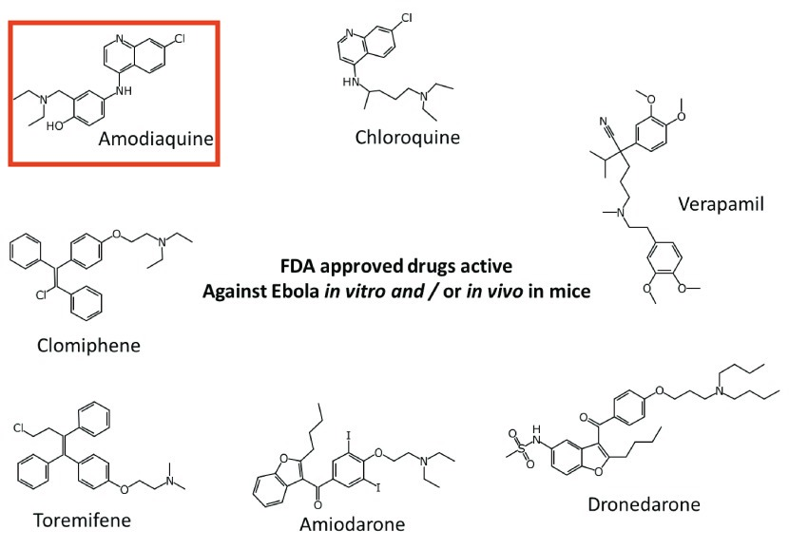
Figure: Src: PMC4358410 Fig. 1. FDA approved drugs of most interest for repurposing as potential Ebola virus treatments.
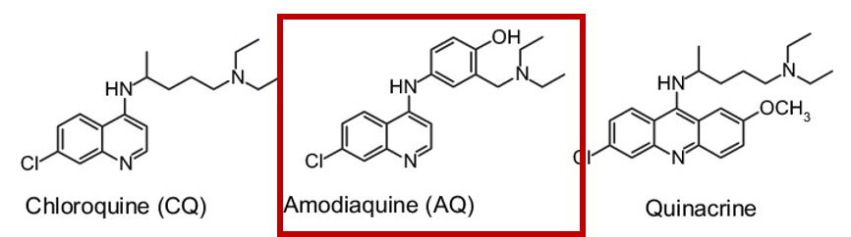
Figure Src: PMC7125724 Fig. 1. Some of the 4-aminoquinoline drug compounds.
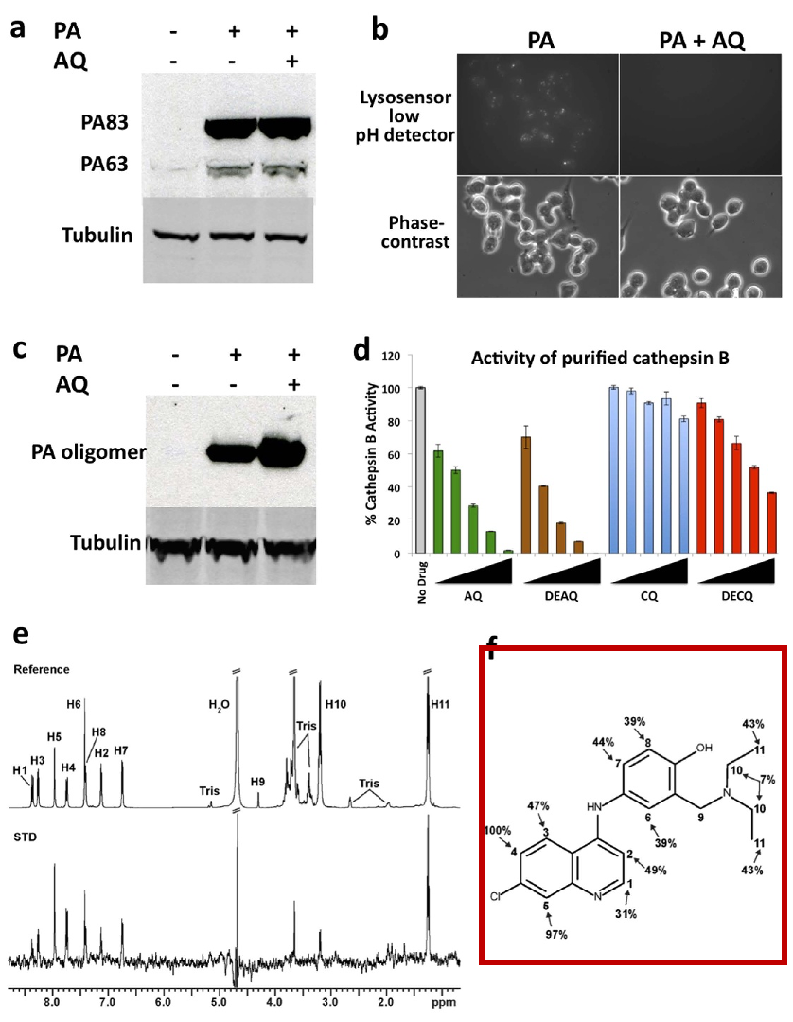
Figure Src: PMC4550849 Fig. 4. Amodiaquine inhibits host cathepsin B. (a) AQ does not inhibit PA binding to RAW264.7 cells. Cells were incubated with AQ for 1h at 4°C before addition of 1μg/mL PA for an additional 1h. Cells were lysed and analyzed by immunoblotting with a PA-specific antibody. (b) AQ neutralizes acidic vesicles. RAW264.7 cells were pre-treated with AQ or vehicle control for 1 h and then treated with 500 ng/ml of PA for an additional hour at 37°C before addition of Lysosensor Green DND-189 for a further 10min. Cells were then visualized by fluorescence microscopy. (c) AQ results in increased abundance of PA pores. Cells were pre-treated with AQ for 1h at 37°C and then were exposed to 1μg/mL of PA at 37°C for 1h. Cells were lysed and analyzed by immunoblotting with a PA-specific antibody. (d). FRET assay showing the activity of purified human cathepsin B without drugs, or with addition of AQ, DEAQ, CQ, or DECQ at 4, 8, 16, 33, or 66μM. (e) 1H-NMR spectra of AQ in the presence of cathepsin B. The reference spectrum of AQ with its atoms labeled (top), and the STD spectrum (bottom) are shown. The data were collected using a protein:ligand ratio of 1:100 with on- and off-resonance saturation at 0.04ppm and 30ppm, respectively. (f) Chemical structure of AQ showing the atom-specific magnitude of the STD effects. The STD effect was calculated according to the formula ASTD = (I0 − Isat)/I0. All STD effects are expressed as a percentage relative to the H4 atom (100%).
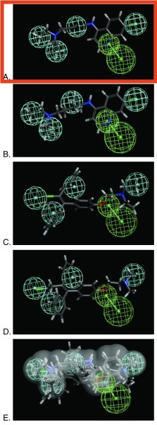
Figure: Src: PMC4304229 Fig 1. Pharmacophore based on 4 hits.

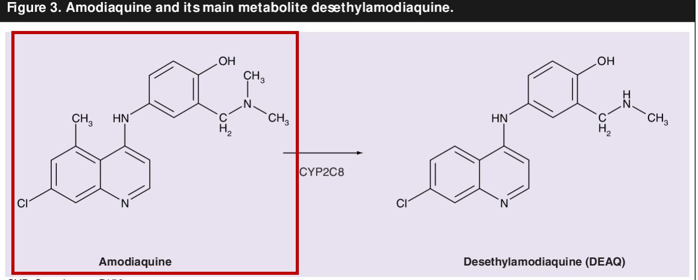
Figure Src: PMC7117598 Fig.3
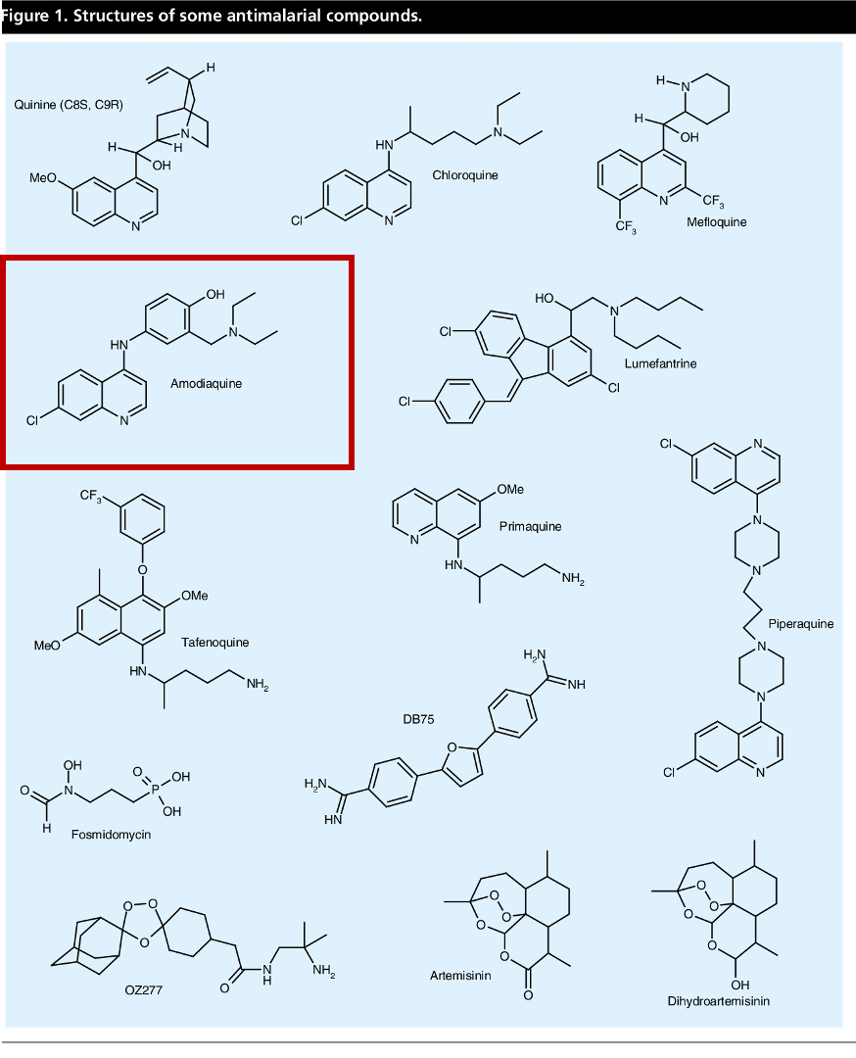
Figure Src: PMC7117597 Fig.1
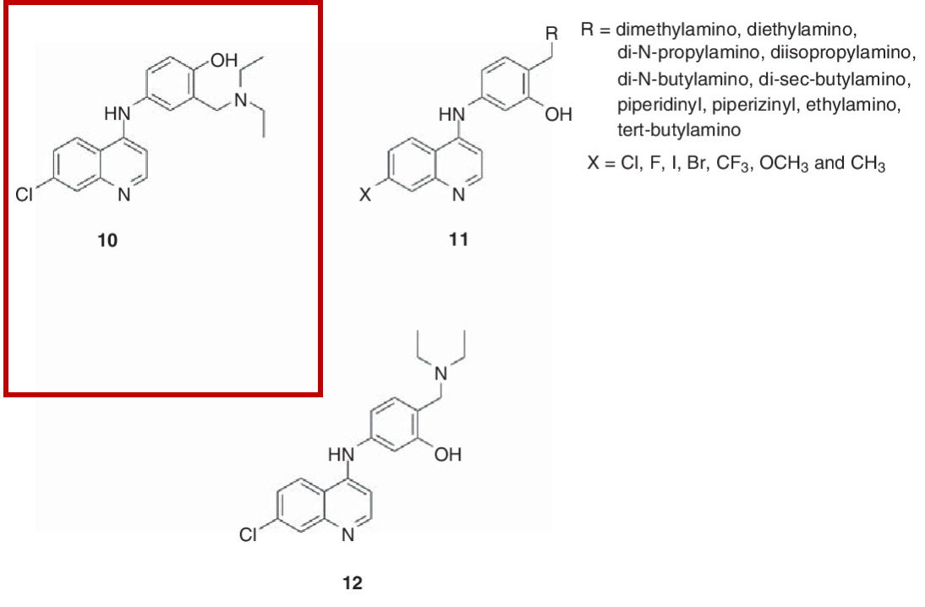
Figure Src: PMC7103710 Fig 4. Amodiaquine and its derivatives.
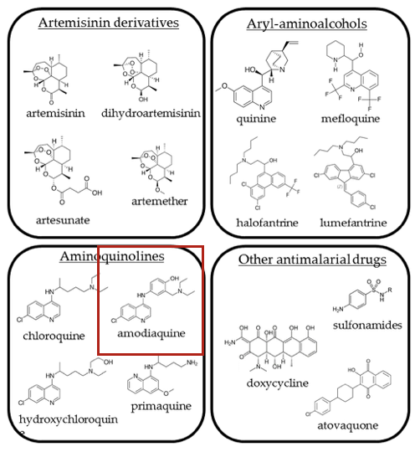
Figure Src: PMC7022795 Fig 1.Chemical structures of the compounds described in the text.
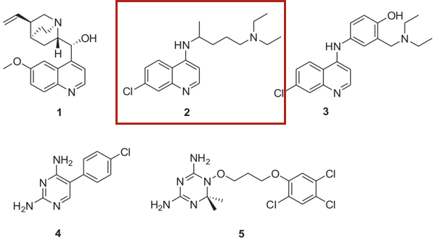
Figure Src: PMC7115513 Chart 1. Antimalarial agents: quinine (1), chloroquine (2), amodiaquine (3), pyrimethamine (4) and WR99210 (5).

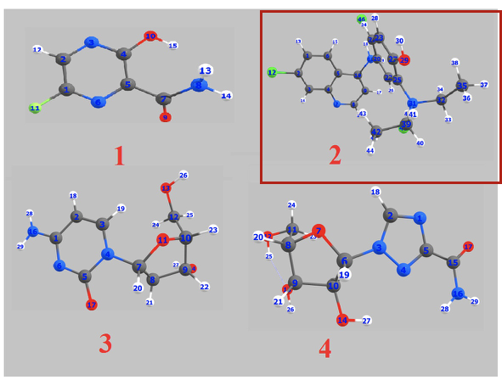
Figure Src: PM32486229 Fig 1 Optimized geometrical structures of present compounds 1–4 with atomic numbering.
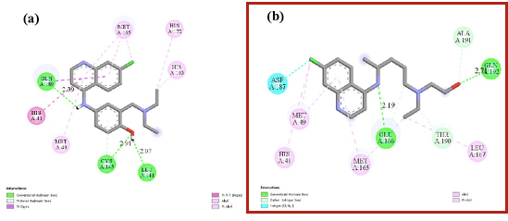
Figure Src: PM32486229 Fig 6.The interacting mode with SARS-CoV-2 Mpro in 2D representations of ligand 2 (a),
hydroxychloroquine (b).

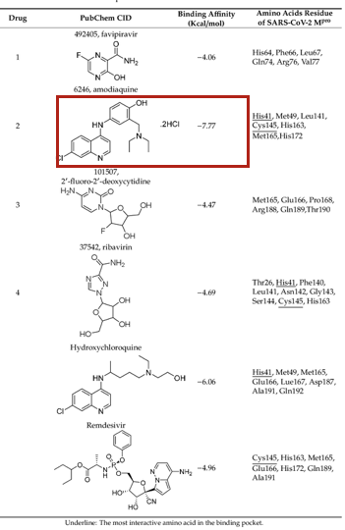
Figure Src: PM32486229 Table 1.Data analysis of the flexible docking of drugs 1–4, hydroxychloroquine and remdesivir in the activDe rsuitge of SARS-CoV-2 MPubrCecheepmtoCr..

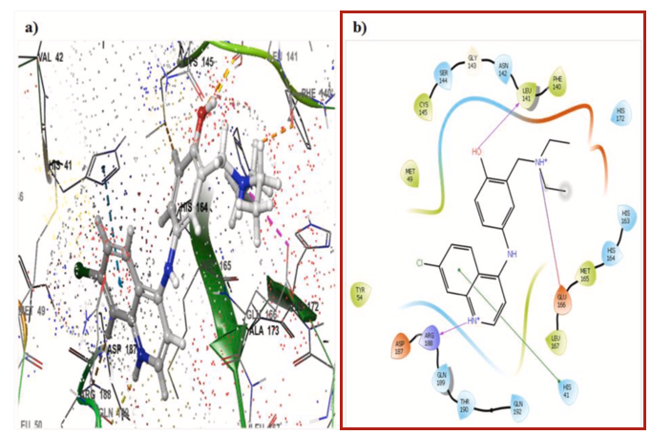
Figure Src: PMC7211761 Fig 4 a). Docked pose of amodiquine (antimalarial drug) molecule with main protease (6LU7) and b). Ligand interaction of amodiquine with 6LU7.

Section 3: Mechanism of action i.e. inhibits viral entry, replication, etc (w/ a pointer to data)

PMID | Chemical (ID) | Gene (ID) | Interaction | InteractionActions
31629065 | Amodiaquine (MESH:D000655) | CYP1A1 (1543) | CYP1A1 protein results in decreased susceptibility to Amodiaquine | decreases^response to substance
31629065 | Amodiaquine (MESH:D000655) | CYP2C8 (1558) | Rifampin inhibits the reaction [CYP2C8 protein results in increased susceptibility to Amodiaquine] | decreases^reaction, increases^response to substance
31629065 | Amodiaquine (MESH:D000655) | BAX (581) | [Rifampin inhibits the reaction [CYP2C8 protein results in increased susceptibility to Amodiaquine]] which results in increased expression of BAX protein | decreases^reaction, increases^expression, increases^response to substance
24113242 | Amodiaquine (MESH:D000655) | RB1 (5925) | Amodiaquine affects the phosphorylation of RB1 protein | affects^phosphorylation
24113242 | Amodiaquine (MESH:D000655) | CCND1 (595) | Amodiaquine affects the expression of CCND1 protein | affects^expression
29281794 | Amodiaquine (MESH:D000655) | NQO2 (4835) | Amodiaquine inhibits the reaction [NQO2 protein results in increased reduction of Vitamin K 3] | decreases^reaction, increases^reduction

Section 4: Was the drug identified by manual or computation screen?

Disease | MERS
PMID, PMCID | Evidence Sentences
26310922  PMC6024778 | From the primary screening, we identified several drugs including chloroquine, amodiaquine, and chloropromazine analogs that have previously been reported as inhibitors of the MERS-CoV by other groups, indicating the validity of our screening results.

Disease | EBOV
PMID, PMCID | Evidence Sentences
29759926  PMC7126639 | Treatment of EBOV-infected patients with these drugs has been associated with a decrease in fatality rate compared to control patients.
32320852  PMC7167229 | An early drug identified by these screens was the antimalarial amodiaquine, … was used for malaria treatment in some Ebola patients ….

Section 5: Who is studying the drug? (Source/lab name)

Researcher | Affiliation
Thanigaimalai Pillaiyar | PharmaCenter Bonn, Pharmaceutical Institute, Department of Pharmaceutical and Medicinal Chemistry, University of Bonn, An der Immenburg 4, D-53121 Bonn, Germany.
Sangeetha Meenakshisundaram | Department of Chemistry, Sri Krishna College of Engineering and Technology, Coimbatore, Tamil Nadu, India.
Manoj Manickam | Department of Chemistry, PSG Institute of Technology and Applied Research, Coimbatore, Tamil Nadu, India.
Murugesan Sankaranarayanan | Department of Pharmacy, Birla Institute of Technology and Science Pilani, Pilani Campus, Pilani, 333031, Rajasthan, India.
Jin Soo Shin | Infectious Diseases Therapeutic Research Center, Korea Research Institute of Chemical Technology (KRICT), Daejeon 34114, Korea.
Eunhye Jung | Virus Research Group, Korea Research Institute of Chemical Technology, Daejeon, Republic of Korea.
Meehyein Kim | Infectious Diseases Therapeutic Research Center, Korea Research Institute of Chemical Technology (KRICT), Daejeon 34114, Korea.
Ralph S Baric | Department of Microbiology and Immunology, University of North Carolina School of Medicine, Chapel Hill NC 27599, USA.
Yun Young Go | Virus Research Group, Korea Research Institute of Chemical Technology, Daejeon, Republic of Korea. yygo@krict.re.kr.
Beatrice Mercorelli | Department of Molecular Medicine, University of Padova, Padova, Italy.
Giorgio Palù | Department of Molecular Medicine, University of Padova, Padova, Italy.
Arianna Loregian | Department of Molecular Medicine, University of Padova, Padova, Italy. Electronic address: rianna.loregian@unipd.it.
Elizabeth A Nelson | Department of Medical Education, Dell Medical School, University of Texas at Austin, Austin, Texas, USA.
Julie Dyall | Integrated Research Facility, National Institute of Allergy and Infectious Diseases, National Institutes of Health, Frederick, MD, 21702, USA. dyallj@niaid.nih.gov.
Thomas Hoenen | Institute of Molecular Virology and Cell Biology, Friedrich-Loeffler-Institut, Greifswald - Insel Riems, Germany.
Alyson B Barnes | Department of Cell Biology, University of Virginia, Charlottesville, Virginia, United States of America.
Huanying Zhou | Tianjin Key Laboratory of Risk Assessment and Control Technology for Environment and Food Safety, Tianjin Institute of Environmental and Operational Medicine, Tianjin 300050, China.
Janie Y Liang | Integrated Research Facility, Division of Clinical Research, National Institute of Allergy and Infectious Diseases, National Institutes of Health, Frederick, Maryland, United States of America.
Julia Michelotti | Integrated Research Facility, Frederick, Maryland.
William H Dewey | Integrated Research Facility, Division of Clinical Research, National Institute of Allergy and Infectious Diseases, National Institutes of Health, Frederick, Maryland, United States of America.
Lisa Evans DeWald | Emergent BioSolutions, Gaithersburg, Maryland.
Richard S Bennett | Integrated Research Facility, Division of Clinical Research, National Institute of Allergy and Infectious Diseases, National Institutes of Health, Research Plaza, Frederick, Maryland, United States of America.
Patrick J Morris | Division of Preclinical Innovation, National Center for Advancing Translational Sciences, National Institutes of Health, Rockville, MD 20850, USA.
Rajarshi Guha | Division of Preclinical Innovation, National Center for Advancing Translational Sciences, National Institutes of Health, Rockville, Maryland, United States.
Carleen Klumpp-Thomas | National Center for Advancing Translational Sciences, 9800 Medical Center Drive, Rockville, MD, 20850.
Crystal McKnight | Division of Preclinical Innovation, National Center for Advancing Translational Sciences, National Institutes of Health, Rockville, MD 20850, USA.
Yu-Chi Chen | Institute of Clinical Nursing, School of Nursing, National Yang-Ming University, Taipei, Taiwan.
Xin Xu | Henan Provincial Engineering Laboratory of Insects Bio-reactor, Henan Provincial Engineering and Technology Center of Health Products for Livestock and Poultry, Henan Provincial Engineering and Technology Center of Animal Disease Diagnosis and Integrated Control, Nanyang Normal University, Nanyang, 473061, PR China.
Amy Wang | Predicine, Inc., Hayward, CA, United States.
Emma Hughes | Department of Bioengineering and Therapeutic Sciences, University of California San Francisco, San Francisco, California, USA.
Scott Martin | DMPK/ADME Research and Early Development, Oncology R&D, AstraZeneca, Cambridge, UK.
Craig Thomas | Research Institute for Sport and Exercise Sciences (RISES), Liverpool John Moores University, Tom Reilly Building, Byrom St. Campus, Liverpool, L3 3AF, UK.
Peter B Jahrling | Integrated Research Facility at Fort Detrick, National Institute of Allergy and Infectious Diseases, National Institutes of Health, Fort Detrick, Frederick, MD, USA.
Lisa E Hensley | Integrated Research Facility, Division of Clinical Research, National Institute of Allergy and Infectious Diseases, National Institutes of Health, Research Plaza, Frederick, Maryland, United States of America.
Gene G Olinger | Integrated Research Facility, Division of Clinical Research, National Institute of Allergy and Infectious Diseases, National Institutes of Health, Frederick, Maryland, United States of America.
Judith M White | Department of Cell Biology, University of Virginia, Charlottesville, Virginia, USA.
Fatah Kashanchi | National Center for Biodefense and Infectious Diseases, George Mason University, Manassas, VA 20110, USA.
Sean Ekins | Collaborations Pharmaceuticals, Inc., 840 Main Campus Drive, Lab 3510, Raleigh, North Carolina, 27606, USA. sean@collaborationspharma.com.
Joel S Freundlich | Department of Pharmacology, Physiology, and Neuroscience, Rutgers University-New Jersey Medical School, Newark, New Jersey 07103, United States.
Megan Coffee | Division of Infectious Diseases and Immunology, Department of Medicine, New York University, NY, USA; Department of Population and Family Health, Mailman School of Public Health, Columbia University, NY, USA.
Sean Ekins | Collaborations Pharmaceuticals, Inc., 840 Main Campus Drive, Lab 3510, Raleigh, North Carolina, 27606, USA. sean@collaborationspharma.com.
Melina Mottin | LabMol - Laboratory of Molecular Modeling and Drug Design, Faculdade de Farmácia, Universidade Federal de Goiás, Goiânia, GO 74605-170, Brazil.
Paulo RPS Ramos
Bruna KP Sousa
Bruno Junior Neves | LabMol - Laboratory of Molecular Modeling and Drug Design, Faculdade de Farmácia, Universidade Federal de Goiás, Goiânia, GO 74605-170, Brazil.
Daniel H Foil | Collaborations Pharmaceuticals Inc., 840 Main Campus Drive, Lab 3510, Raleigh, North Carolina 27606, United States.
Kimberley M Zorn | Collaborations Pharmaceuticals Inc., 840 Main Campus Drive, Lab 3510, Raleigh, North Carolina 27606, United States.
Rodolpho C Braga | InsilicAll, São Paulo, SP 04363-090, Brazil.
Megan Coffee | Division of Infectious Diseases and Immunology, Department of Medicine, New York University, NY, USA; Department of Population and Family Health, Mailman School of Public Health, Columbia University, NY, USA.
Christopher Southan | TW2Informatics Ltd, Göteborg 42166, Sweden.
Ana C Puhl | Collaborations Pharmaceuticals, Inc., 840 Main Campus Drive, Lab 3510, Raleigh, North Carolina, 27606, USA.
Carolina Horta Andrade | LabMol - Laboratory of Molecular Modeling and Drug Design, Faculdade de Farmácia, Universidade Federal de Goiás, Goiânia, GO 74605-170, Brazil; Department of Genetics, Evolution, Microbiology and Immunology, Institute of Biology, University of Campinas, Campinas, SP 13083-864, Brazil.
Siwaporn Boonyasuppayakorn | Applied Medical Virology Research Unit, Department of Microbiology, Faculty of Medicine, Chulalongkorn University, Bangkok 10330, Thailand.
Erin D Reichert | Department of Microbiology & Immunology, Georgetown University, USA. Electronic address: erin.reichert@dtra.mil.
Mark Manzano | Department of Microbiology-Immunology, Northwestern University Feinberg School of Medicine, Chicago, IL 60611, USA.
Kuppuswamy Nagarajan | R&D Centre, Alkem Laboratories Ltd. , Peenya Ind. Area, 3rd Stage, Bangalore 560 058, India.
Radhakrishnan Padmanabhan | Department of Microbiology and Immunology, Georgetown University, Washington, DC, USA paa9@georgetown.edu rp55@georgetown.edu.
Leeor Zilbermintz | Keck Graduate Institute, Claremont, CA 91711, USA.
William Leonardi | Keck Graduate Institute, Claremont, CA 91711, USA.
Sun-Young Jeong | Keonyang University College of Nursing, Daejeon, Korea.
Megan Sjodt | Department of Biological Chemistry and Molecular Pharmacology, Blavatnik Institute, Harvard Medical School, Boston, MA, USA.
Ryan McComb | Private Practice of Orthodontics in Los Angeles.
Chi-Lee C Ho | Department of Microbiology, Immunology and Molecular Genetics , University of California, Los Angeles , 609 Charles E. Young Drive East , Los Angeles , California 90095 , United States.
Cary Retterer | United States Army Medical Research Institute of Infectious Diseases (USAMRIID), 1425 Porter Street, Frederick, MD, 21702, USA.
Dima Gharaibeh | United States Army Medical Research Institute of Infectious Diseases (USAMRIID), 1425 Porter Street, Fort Detrick, Frederick, MD, 21702, USA.
Rouzbeh Zamani | United States Army Medical Research Institute of Infectious Diseases (USAMRIID), 1425 Porter Street, Frederick, MD, 21702, USA.
Veronica Soloveva | U.S. Army Medical Research Institute of Infectious Diseases, Frederick, MD, 21702-5011, USA.
Sina Bavari | United States Army Medical Research Institute of Infectious Diseases (USAMRIID), Frederick, MD, USA.
Anastasia Levitin | School of Applied Life Sciences , Keck Graduate Institute , 535 Watson Drive , Claremont , California 91711 , United States.
Joel West | Keck Graduate Institute, Claremont, CA 91711.
Kenneth A Bradley | Department of Microbiology, Immunology and Molecular Genetics , University of California, Los Angeles , 609 Charles E. Young Drive East , Los Angeles , California 90095 , United States.
Robert T Clubb | Department of Chemistry and Biochemistry, University of California, Los Angeles, USA. rclubb@mbi.ucla.edu.
Stanley N Cohen | Department of Genetics, Stanford University School of Medicine, Stanford, CA 94305, USA.
Vivek Gupta | Department of Pharmaceutical Sciences, College of Pharmacy and Health Sciences, St. John's University, 8000 Utopia Parkway, Queens, New York, 11439, USA. guptav@stjohns.edu.
Mikhail Martchenko | School of Applied Life Sciences , Keck Graduate Institute , 535 Watson Drive , Claremont , California 91711 , United States.
K Abraham Peele | Department of Bio-Technology, Vignan's Foundation for Science, Technology & Research, Guntur, Andhra Pradesh, India.
P Chandrasai | Department of Bio-Technology, National Institute of Technology, Warangal, 506004, Telangana, India.
T Srihansa | Department of Bio-Technology, Vignan's Foundation for Science, Technology & Research, Guntur, Andhra Pradesh, India.
S Krupanidhi | Department of Bio-Technology, Vignan's Foundation for Science, Technology & Research, Guntur, Andhra Pradesh, India.
A Vijaya Sai | Department of Bio-Technology, Vignan's Foundation for Science, Technology & Research, Guntur, Andhra Pradesh, India.
D John Babu | Department of Bio-Technology, Vignan's Foundation for Science, Technology & Research, Vadlamudi, 522213, Andhra Pradesh, India.
M Indira | Department of Bio-Technology, Vignan's Foundation for Science, Technology & Research, Vadlamudi, 522213, Andhra Pradesh, India.
A Ranganadha Reddy | Department of Bio-Technology, Vignan's Foundation for Science, Technology & Research, Vadlamudi, 522213, Andhra Pradesh, India.
TC Venkateswarulu

Section 6: In vitro Data available (cell line used, assays run, viral strain used, cytopathic effects, toxicity, LD50, dosage response curve, etc)
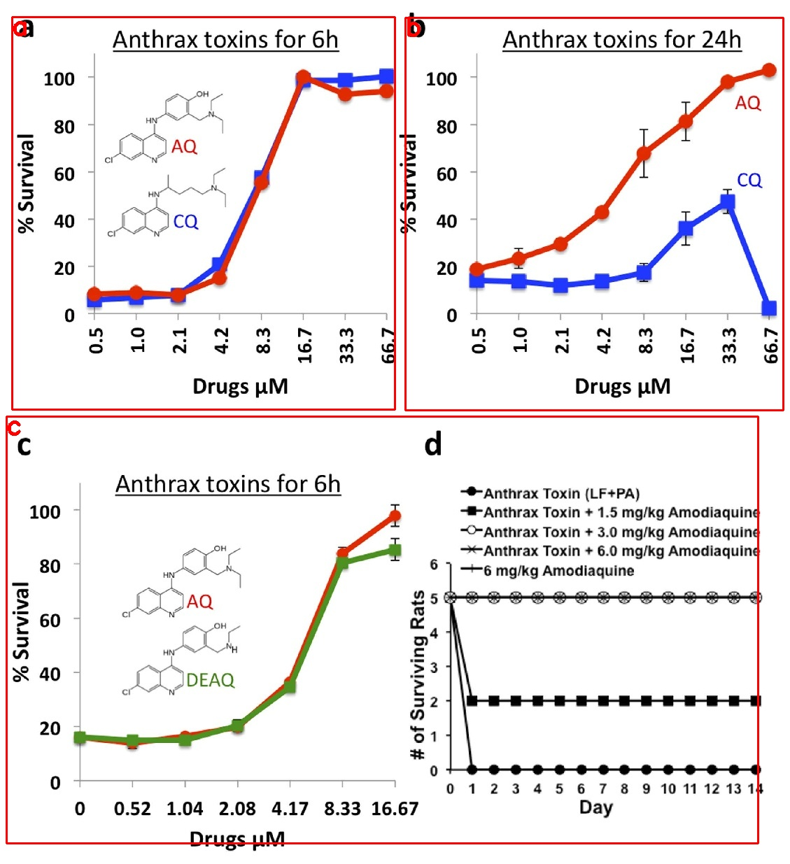
Src: PMC4550849 Fig 2. The anti-LF-PA efficacy of Amodiaquine (AQ) and its metabolite Desethylamodiaquine (DEAQ) in intro and in vivo. Amodiaquine and JHCCL available structural analogs were tested for their ability to inhibit LF-PA-mediated cytotoxicity. RAW264.7 cells were seeded at 1×104 cells/well on 96-well plates and the following day were incubated with indicated doses of Amodiaquine or Chloroquine for 1h, followed by either 6h (a) or 24h (b) intoxication with 500ng/mL PA+500ng/mL LF. Cell viability was determined by MTT assay (Materials and Methods) and is shown as the percentage of survivors relative to cells not treated with drugs. AQ and DEAQ were tested for their ability to inhibit LF-PA-mediated toxicity in (c) RAW264.7 cells and in (d) Sprague-Dawley rats. RAW264.7 cells were seeded at 1 × 104 cells/well on 96-well plates and the following day were incubated with indicated doses of AQ or DEAQ for 1 h, followed by 6h intoxication with 500ng/mL PA+500ng/mL LF. Survival curves of groups of male Sprague-Dawley rats challenged intravenously with 12μg LF and 40μg PA along with varying amounts of AQ (1.5, 3.0, and 6.0mg/kg). Control groups of rats either received toxin only or 6.0mg/kg of AQ only.
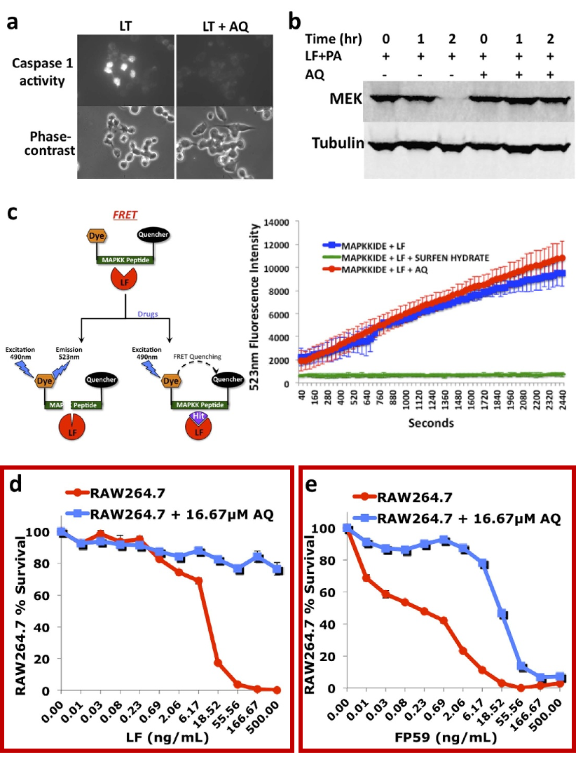
Src: PMC4550849 Fig. 3. Amodiaquine inhibits cellular entry of LF. (a) AQ inhibits LT-mediated caspase-1 activation. RAW264.7 cells were seeded and allowed to adhere overnight, and then incubated with 16μM AQ or DMSO for 1h before addition of 500ng/mL PA+LF for 2h. FLICA was added for a further 1h and then cells analyzed by fluorescence microscopy. (b) AQ inhibits LT-mediated cleavage of MEK-2. RAW264.7 cells were incubated with AQ or DMSO for 1h before addition of vehicle control or 1μg/mL PA+LF for up to 2h. Cells were lysed and analyzed via immunoblotting with a MEK-2–specific antibody. Tubulin was used as a loading control. (c) FRET data showing fluorescence emission from three reactions, where 5.8μg/ml LF cleaves fluorescently labeled MAPKK peptide without drugs, in the presence of a known LF inhibitor, 16μM surfen hydrate, or in the presence of 16μM AQ. (d and e) AQ protects cells from PA+FP59. RAW264.7 cells were preincubated with a titration of AQ for 1h, followed by a 6h intoxication with 500ng/mL PA+LF (d) or FP59 (e). Cell viability was measured via MTT.

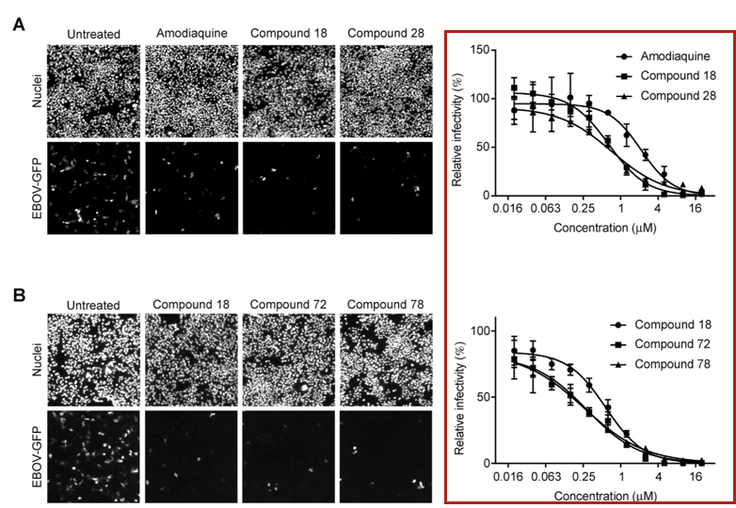
Src: PMC6374029 Fig. 1. Amodiaquine and its derivatives inhibit EBOV infection. Huh7 cells were challenged with recombinant EBOV encoding GFP (EBOV-GFP) in the presence of the indicated concentrations of amodiaquine, compound 18 or compound 28 (A) or compounds 18, compound 72 or compound 78 (B). After 24 h, cells were fixed, the nuclei were stained with Hoescht 33342 and images were captured by microscopy. The images of cells treated with each compound at 2.5 μM and untreated cells are shown (left panels). Infected cells expressing GFP and total cell numbers were counted to calculate the infectivity, which was normalized to those of untreated controls to obtain relative infectivity. They were plotted as a function of compound concentration to draw dose-response curves (right panels). All measurements were performed in at least triplicate and shown as mean ± SD. Similar results were obtained in replicate experiments.
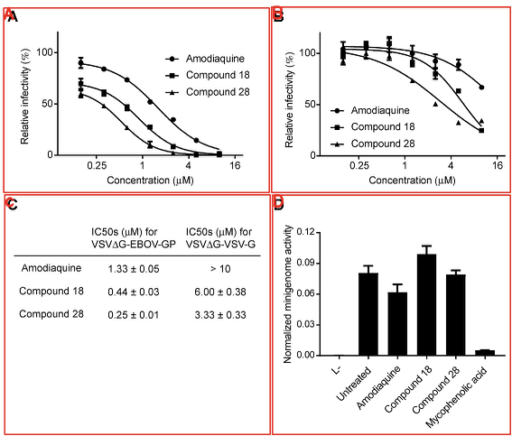
Src: PMC6374029 Fig.2. Amodiaquine and its derivatives inhibit glycoprotein-dependent entry of EBOV. To address the effects of compounds on virus entry into the cell, pseudotyped viruses bearing the glycoprotein of (A) EBOV or (B) VSV and encoding a firefly luciferase reporter were used. Huh7 cells were treated with the indicated doses of each compound and challenged with either pseudotyped virus. Luciferase activities were measured and normalized to those of untreated controls (mean ± SD, n = 3). Each data set is representative of two independent experiments. (C) Comparison of activity of amodiaquine, compounds 18 or compound 28 for inhibition of pseudotyped virus infection. Calculated IC50 values are shown as mean ± SD from 2 independent experiments performed using triplicate samples. (D) To assess EBOV transcription and replication, Huh7 cells were transfected with a plasmid expressing EBOV minigenome RNA encoding a firefly luciferase reporter, plasmids expressing each component of the EBOV polymerase complex and a plasmid expressing a renilla luciferase reporter. Twenty-four hours later, cells were treated with DMSO (untreated), amodiaquine (10 μM), compound 18 (10 μM), compound 28 (10 μM) or mycophenolic acid (10 μM) as a positive control. Luciferase activities were measured after additional 24 h. Firefly luciferase activities normalized to renilla luciferase activities are shown (mean ± SD, n = 3). Each data set is re- presentative of two independent experiments.
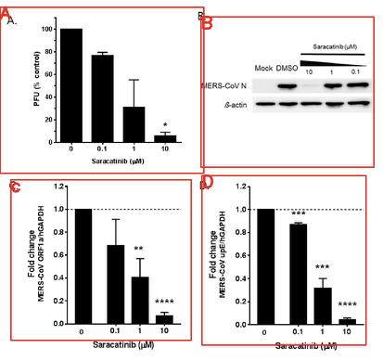
Src: PMC6024778 Fig.2. In vitro antiviral activity of saracatinib against MERS-CoV. Antiviral efficacy of saracatinib against MERS-CoV in Huh-7 cells. MERS-CoV infected Huh-7 cells were treated with saracatinib at indicated concentrations for 24 h, after which culture supernatant and cell lysates were collected. (A) Amount of infectious viral particles released to culture supernatants was determined by plaque assay. (B) MERS-CoV nucleocapsid (N) protein levels in lysates of infected cells were determined by Western blot analysis. Immunoblot detection of β-actin is shown as a loading control. (C,D) Quantification of intracellular MERS-CoV RNAs by RT-qPCR assay. Total RNA was isolated from lysates of infected cells for quantification of intracellular MERS-CoV RNA levels (ORF1a and upE) and results were normalized to GAPDH mRNA. Data represent means (±SD) of at least two independent experiments performed in duplicate. Significant differences are indicated by * p < 0.05, ** p < 0.01, *** p < 0.001, **** p < 0.0001.
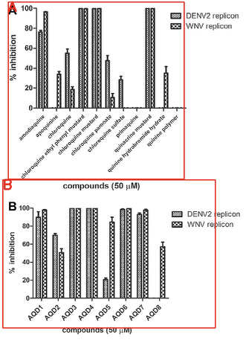
Src: PMC4523242 Fig. 1. Screening of quinoline derivatives for inhibition of replicon replication (A & B). BHK-21/DENV2 and Vero/WNV replicon cells (􏰎104 in 100 ll) were seeded and incubated for 6 h. Compounds were added to the final concentrations of 50 lM in 1% DMSO, the incubation continued for 24 h, and the Rluc activities were measured. MPA (5 lM in 1% DMSO) and 1% DMSO were used as 100% and 0% inhibition controls. Error bars represent the standard error of the mean from triplicates. Experiments were repeated to confirm the findings.

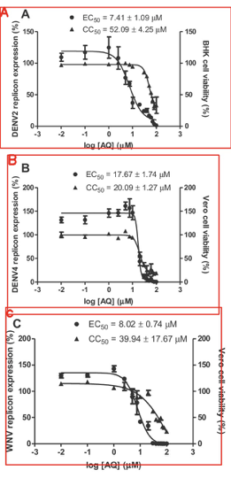
Src: PMC4523242 Fig. 2. EC50 and CC50 values of AQ for replicon inhibition and viability of replicon expressing cells. (A) BHK-21/DENV2 replicon, (B) Vero/DENV4 replicon, and (C) Vero/WNV replicon cells (􏰎104 in 100 ll) were seeded and incubated for 24 h. AQ at 0, 0.01, 0.1, 1, 2.5, 5, 7.5, 10, 20, 30, 40, 50, 60, 70, 80, or 100 lM in 1% DMSO were added in triplicate wells. Cells were incubated at 37 °C for 48 h, washed, lysed, and Rluc activities were measured. Cytotoxicity was measured in the same replicon expressing cells treated with the various concentrations of AQ as described under Section 2. The results were confirmed by two independent experiments.
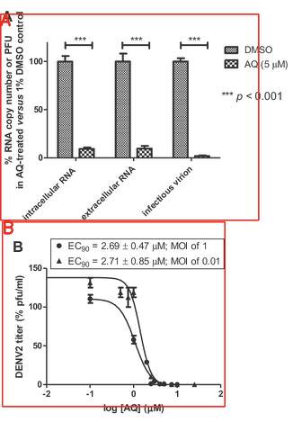
Src: PMC4523242 Fig. 3. Inhibition by AQ of DENV2 replication analyzed by qPCR and infectivity (plaque) assay. (A) qPCR and infectivity. BHK-21 cells were infected with DENV2 (MOI of 1) and treated with AQ (5 lM) or no-AQ control (1% DMSO) during infection and post-infection. Cells were incubated for 72 h at 37 °C and intracellular and extracellular RNAs were analyzed by qPCR or by plaque assay as described under Section 2. The relative amounts of viral RNA copy number or PFU in AQ-treated cells were calculated as % of the amounts in AQ-untreated cells. Each sample was tested in duplicate and results were confirmed by three independent experiments. Difference between AQ treated and 1% DMSO-treated groups derived from each approach was evaluated by paired t-test, two tailed. (B) EC90 values for inhibition of DENV2 infectivity by AQ. BHK-21 cells were infected with DENV2 (MOI of 1) and treated with AQ at 0.1, 0.5, 1, 2.5, 5, or 10 lM, or infected with DENV2 (MOI of 0.01) and treated with 0.01, 0.1, 0.5, 0.75, 1, 2.5, 5, 7.5, 10, or 25 lM, during infection and post-infection. Incubation was done at 37 °C and the supernatants were collected at 72 h (MOI of 1) or 96 h (MOI of 0.01). The virus titers were determined by plaque assay. EC90 values were calculated using GraphPad Prism v5 software. Data represented duplicates of two independent experiments.
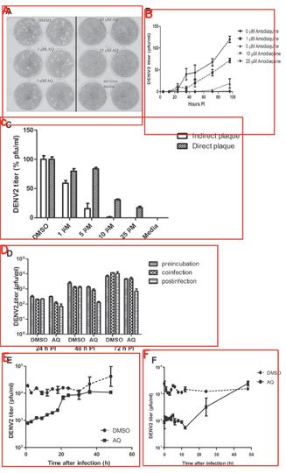
Src: PMC4523242 Fig. 4. Time-course analysis of AQ inhibition of DENV2 infectivity. (A and B) BHK-21 cells were infected with DENV2 (MOI of 0.01). Cells were washed with PBS and incubated with 3 ml of maintenance medium. AQ at 0, 1, 5, 10, or 25 lM in 1% DMSO or 1% DMSO alone, was added and the incubation continued at 37 °C. Supernatants were sampled at 4, 12, 24, 36, 48, 72, and 96 h post-infection. DENV2 infectivity was analyzed by plaque assay. (C) Measurement of AQ inhibition of DENV2 infectivity by direct plaque assay. BHK-21 cells (􏰎105 cells in 1 ml) were seeded into a 12-well plate. AQ at final concentrations of 0, 1, 5, 10, or 25 lM in 1% DMSO were added to DENV2 (MOI of 0.01) during adsorption for 1 h at 37 °C. Cells were washed with PBS and maintained with overlay medium containing 1% methylcellulose without AQ during post-infection as described in Section 2. Plaques (pfu/ml) were counted after 3–4 days of incubation and the titers were normalized using no-AQ control as 100%. Plaque assay was also performed by incubation with AQ at 0, 1, 5, 10, 25 lM in 1% DMSO added during DENV2 infection (MOI of 0.01). AQ was present during post-infection period for 96 h. Supernatants were collected at 96 h post-infection for plaque assay. Titers (PFU/ml) were normalized to those obtained with no-AQ control taken as 100%. Data represented means and SEM of two independent experiments. (D) Order of addition assay. This experiment was performed as described under Section 2. AQ (5 lM in 1% DMSO) and DENV2 (MOI of 1) were treated in one of 3 ways. In (1), AQ and the virus were pre-incubated at 37 °C for 15 min before adsorption to BHK-21 cells for 1 h; in (2), AQ and the virus were added to BHK-21 cells together and incubated for 1 h; in both cases, cells were washed and incubated with the maintenance medium without AQ. In (3), AQ was added after virus adsorption and wash with PBS (post-infection). AQ was present throughout the duration of the experiment. Supernatants were collected at 24, 48, and 72 h post-infection for plaque assay. DMSO (1%) alone was used as mock-infection control. Error bars indicated the standard error of the means of experiments done in duplicate. The results were confirmed by an independent set of experiments. (E) Time of addition assay. This experiment was performed as described under Section 2. AQ (5 lM in 1% DMSO) was added to DENV2 infected BHK-21 cells (MOI of 1) at 1, 3, 6, 9, 12, 15, 18, 21, 24, 30, 36, or 48 h post-infection. Supernatants were collected at 72 h post-infection for analysis of the viral titers. Error bars indicated the standard error of the means of experiments done in duplicate. Results were confirmed by an independent set of experiments. (F) Time of addition assay to probe the AQ effect on viral translation. AQ (5 lM in 1% DMSO) or 1% DMSO alone was added to DENV2-infected BHK-21 cells (MOI of 1) at 1, 2, 3, 4, 5, 6, 8, 10, 12, 24, or 48 h post-infection. Supernatants were collected at 48 h post- infection for plaque assay. Error bars indicated the standard error of the means of experiments done in duplicate.
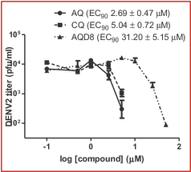
Src: PMC4523242 Fig. 5. Structural determinants of AQ for inhibition of DENV2 infectivity. BHK-21 cells were infected with DENV2 in duplicate wells at a MOI of 1. AQ at 0.1, 0.5, 1, 2.5, 5, or 10 lM as well as CQ or AQD8 at 0.1, 0.5, 1, 2.5, 5, 10, 25, or 50 lM in 1% DMSO were added to the virus-infected cells. Cells were incubated at 37 °C for 72 h. Supernatants were collected and the virus titers were determined by plaque assay. The EC90 values were determined as described under Section 2. The results were confirmed by an independent set of experiments. Structures of AQ, CQ, and AQD8 are shown in Fig. S2.

Disease | COVID-19
PMID, PMCID | Evidence Sentences
32395606  PMC7211761 | The RMSD of three complexes fall between 0.15 and 0.25 nm and inferred that the compounds lopinavir, amodiquine, and theaflavin digallate had undergone good conformational changes while binding, and maintained close affinity with the binding site of the main protease.

Disease | EBOV
PMID, PMCID | Evidence Sentences
25653841  PMC4304229 | The antimalarials chloroquine and amodiaquine docked favorably in VP35.  Previously estradiol was suggested to be active in the EBOV pseudotype assay in vitro. Amodiaquine, chloroquine, clomiphene and toremifene can be used as positive controls for future screens.

Section 7: Animal Data Available (what animal model, LD50, dosage response curve, etc)

Disease | EBOV
PMID, PMCID | Evidence Sentences
25789163  PMC4358410 | In one study, the antimalarials amodiaquine and chloroquine ( Figure 1) were found to be active using in vitro cell culture assays and an in vivo mouse model .
31882748  PMC6934550 | We investigated the potential anti-EBOV effect of amodiaquine in a well-characterized nonhuman primate model of EVD. Using a similar 3-day antimalarial dosing strategy as for human patients, plasma concentrations of amodiaquine in healthy animals were similar to those found in humans.  Effect of amodiaquine treatment in animals infected with Ebola virus. Rhesus macaques (3 animals in group 1, 6 animals each in groups 2 and 3) were exposed IM to 1, 080 PFU EBOV Makona variant and received either vehicle control (group 1, black) or amodiaquine treatment on days 0, 1, and 2 (group 2, blue) or on days 3, 4 and 5 (group 3, red).

Disease | Infectious disease
PMID, PMCID | Evidence Sentences
26310922  PMC4550849 | The toxin mixture was prepared for each group by mixing 12 mug of LF with 40 mug of PA or with 1.5, 3.0, or 6.0 mg/kg of Amodiaquine in a 500-mul volume per rat.

Section 8: Clinical trials on going (what phase, facility, target population, dosing, intervention etc)

Disease | Malaria
PMID, PMCID | Evidence Sentences
23534360  PMC7099626 | Indeed, the 4-aminoquinoline piperaquine has recently entered the clinic (in combination with dihydroartemisinin), while another 4-aminoquinoline, ferroquine, is in Phase IIb clinical trials. In addition, the 4-aminoquinoline, amodiaquine, and the quinoline methanol, mefloquine, as well as the aryl methanol, lumefantrine, are all currently crucial components of ACT.

Section 9: Funding source (who is funding each of the above, it might be different for in vitro vs animal vs clinical)

PMCID | Trial Type | Funding source
PMC4550849 | Vitro Data | We acknowledge the Ralph M. Parson’s Foundation award awarded to K.G.I. (PI Dr. Steven Casper). R.T.C. and M.S. acknowledge grant support from the National Institutes of Health (R01 AI52217 and F31GM101931, respectively).
PMC7211761 | Vitro Data | The authors acknowledge to VFSTR (Deemed to be university) and DST-FIST (LSI- 576/2013) networking facility to carry out this work.
PMC4358410 | Animal Data | Two independent studies funded by the US Defense Threat Reduction Agency in 2013 identified FDA approved drugs worthy of further evaluation.
PMC6934550 | Animal Data | The research presented in this publication was supported by the Division of Intramural Research of the National Institute of Allergy and Infectious Diseases (NIAID); Integrated Research Facility (NIAID, Division of Clinical Research); Battelle Memorial Institute’s prime contract with NIAID (Contract # HHSN272200700016I); and SRI International’s prime contract with NIAID (contract #HHSN2722011000221)
PMC7099626 | Clinical trials

Section 10: List of relevant sources to pull data from.

